**Biology Quiz by Evergreen Studios**

Contents

Game Background 3

User Requirements 4

Designs 5

Splash 5

Login 6

Register 7

Menu 8

Question One 9

Question Two 10

Question Three 11

Question Four 12

Question Five 13

High Scores 14

Help 15

Testing 16

Corrective Action 45

Evaluation 64

# Game Background

My Biology Teacher Dr Connor showcased to me an interest in a quiz that would help her AS level Biology students to learn and understand the course in a fun an engaging way. The Biology course is very intensive and there is a lot to cover, which leads to a lack of motivation for students to learn the content.

The demographic for this game will be 16-17 years who struggle to find the concentration for studying the AS course and need a more entertaining way to learn the course. In order to achieve this, the quiz would have to act more like a game in disguise of a learning tool to entice the students to use it.

The game should allow pupils to register an account, and make it more personal by being able to select an avatar that they would identify themselves with. Pupils should be allowed to login, with a hint provided for forgotten passwords, given that the username entered is valid. A menu screen should be displayed that is easy to navigate and allows the player to either take the quiz or log out. Questions should be of a wide variety of make the game more entertaining sand engaging. A round of questions should be under timed conditions to make it more challenging and exciting for the player. As well, questions should have a different range of ways to answer, for example on Question Two the player can use keys to move a bucket to show the way water moves into cells by osmosis, and on Question 3 drag and drop is utilised to match a cell description image to a cell type. On completion of the quiz, the player should be met with a leader-board table that displays the high scores of past players. This makes the game more competitive for players and encourages replay-ability. The game should have images and colours that look professional and that are associated with biology. The game should be designed so that players can replay the game and get a new experience each time due to the randomization of players.

# User Requirements

1. The game should allow users to create an account with an avatar
2. The player should be given feedback for each question
3. The game should have a clean and professional interface design
4. The player should be able to login to their account
5. Players should be allowed a hint for their forgotten password, provided their username is correct
6. The game should randomise questions to create a different experience for each user
7. The player should be able to sign out without the need to close the game
8. A help screen should always be available for the player
9. The game should include a range of ways to answer questions, for example using keys or drag and drop
10. Timers should be included on at least one of the questions to make the game more challenging
11. A high score board should be available for players to allow comparison of scores
12. The game should save a player’s total score
13. The game should store the player’s account for future login access
14. There should be restrictions and validation checks in place for account creation, for example passwords must be longer than 8 characters
15. The help screen should be used to display the rules to the player
16. A progress bar should be displayed on questions with timers to tell a player how long they have left on the question
17. The player’s username and avatar must be displayed on every question
18. The game must contain login, register, and main menu screens that are easy to navigate
19. The player must be able to replay the game if they want
20. Instructions for each question should be available at the top of each screen on each question
21. The splash screen should contain a GIF image and the company name
22. Players should be made to confirm their password when registering to prevent them registering with a password they didn’t intend
23. A menu-strip should be present on all questions for access to extra help
24. A login screen should allow players to enter their username and password, have hints for forgotten passwords and the option to create an account
25. The player’s total score of the previously completed questions should be displayed
26. Timed questions should be paused when help is displayed

# Designs

## Splash

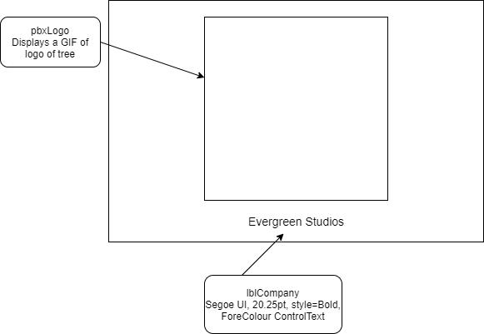

## Login

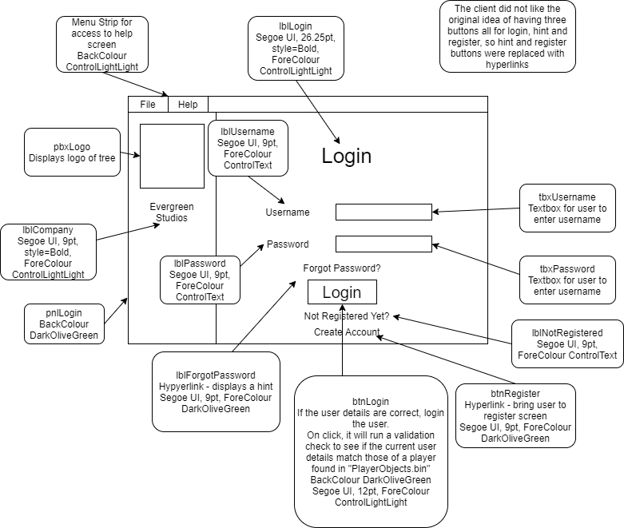

## Register

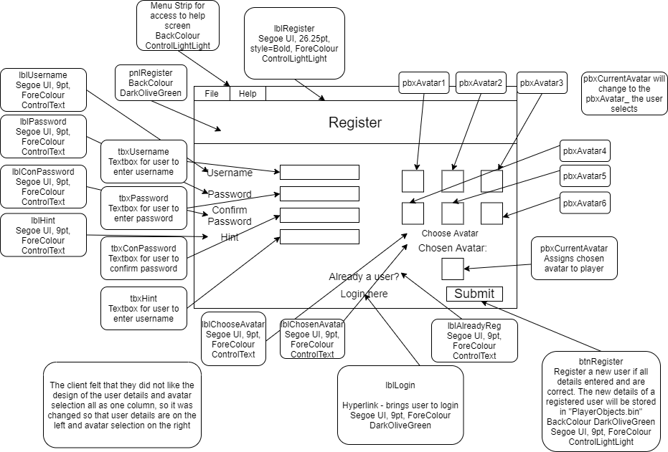

## Menu

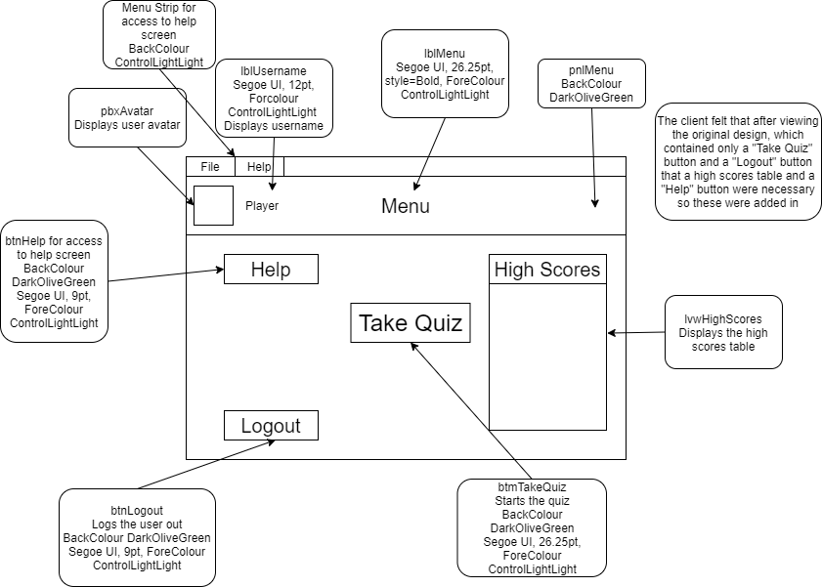

## Question One

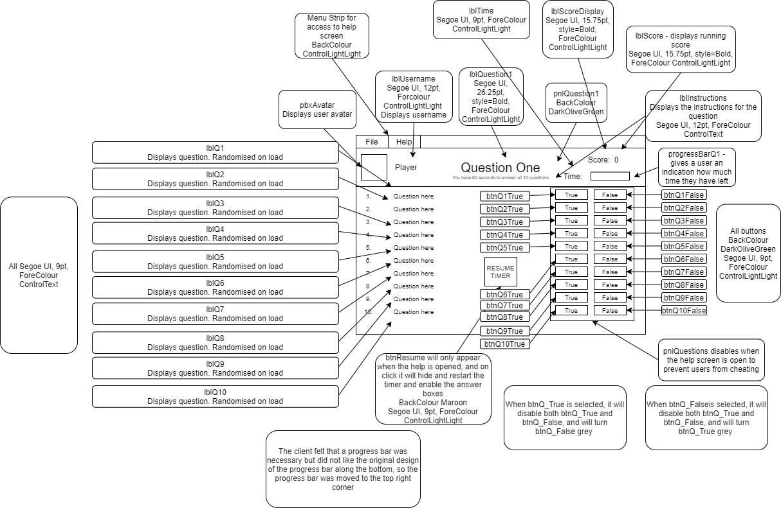

## Question Two

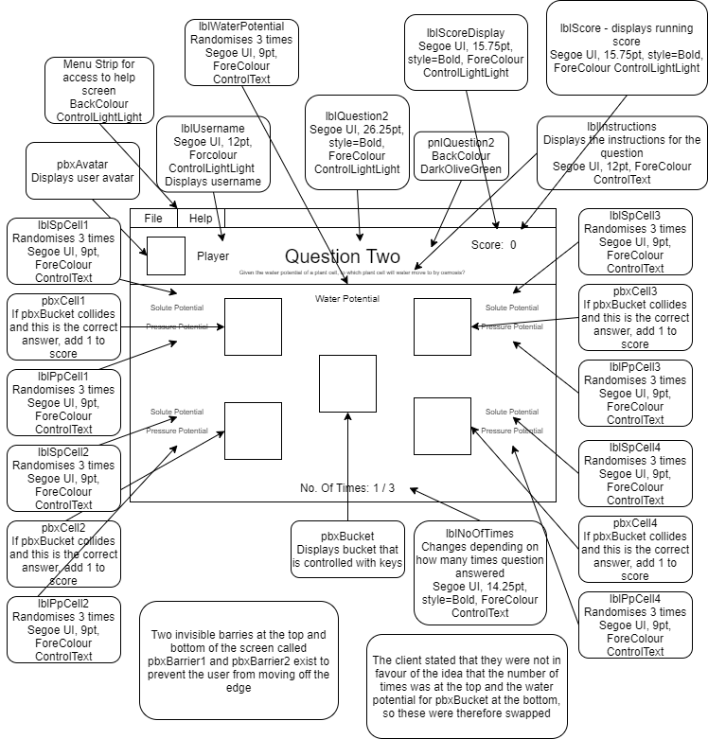

## Question Three

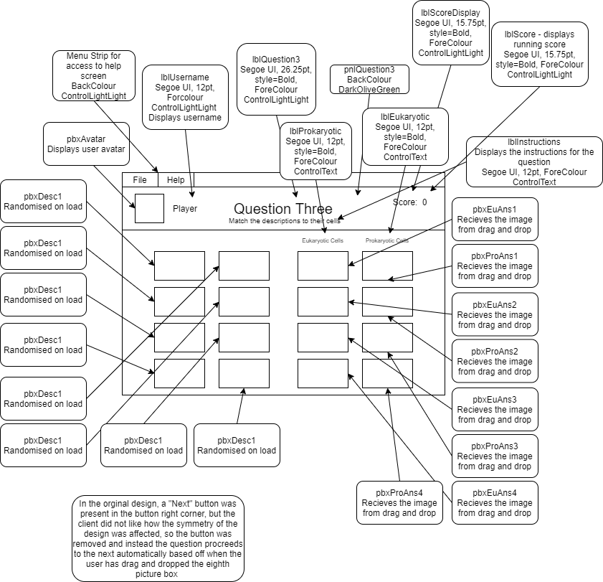

## Question Four

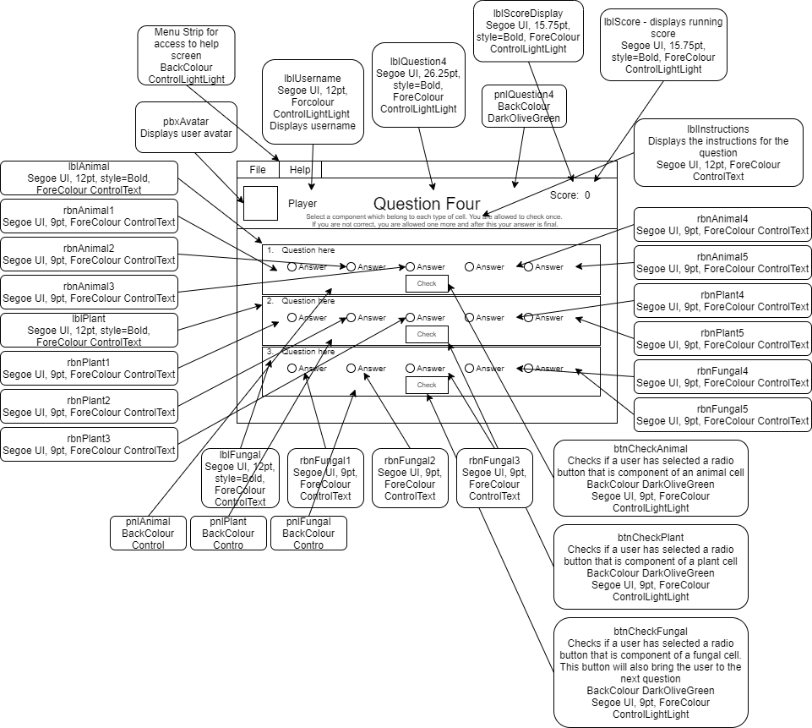

## Question Five

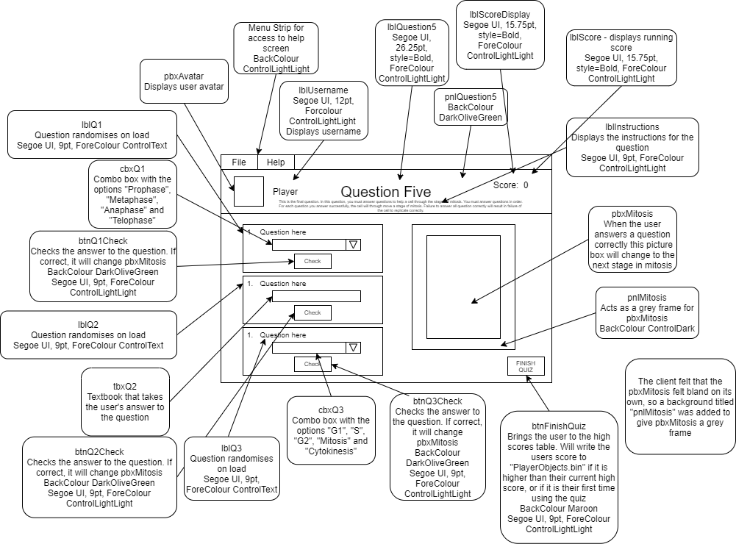

## High Scores

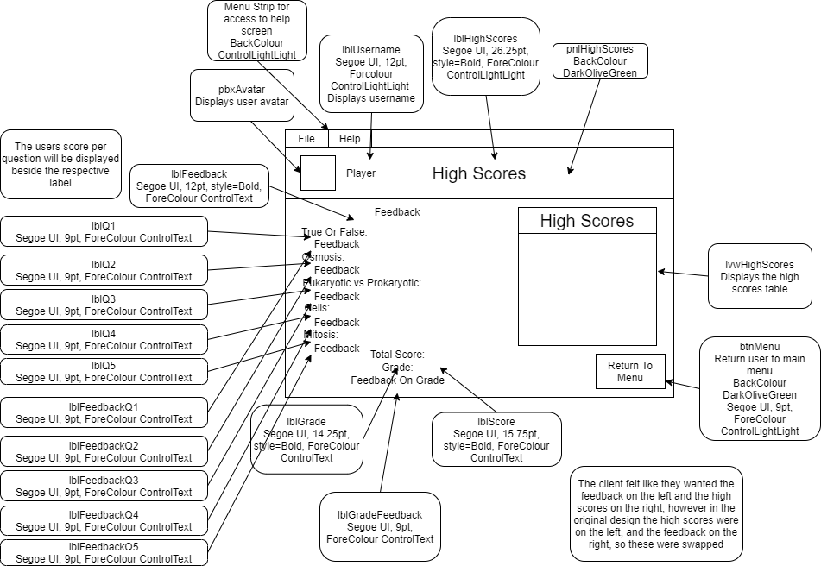

## Help

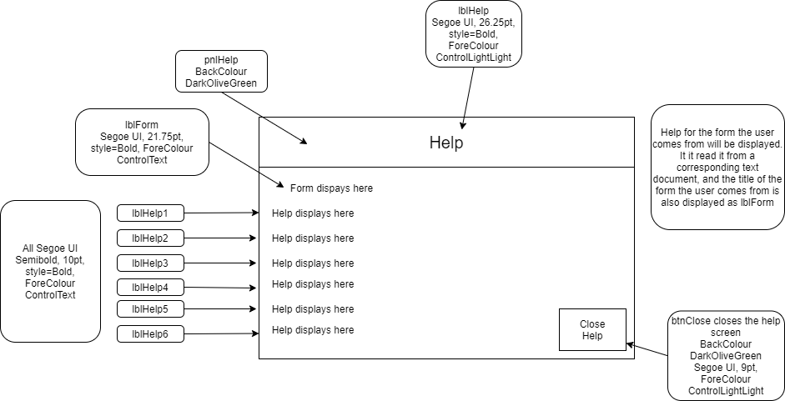

# Testing

|  |  |  |  |  |  |  |  |
| --- | --- | --- | --- | --- | --- | --- | --- |
| **Test No.** | **Form Being Tested** | **Reason For Test** | **Link To User Requirement** | **Test Data** | **Expected Outcome** | **Pass? *✓* / 𝑥** | **Corrective Action #** |
|  | **frmSplash** | Splash screen to display gif and change form to frmLogin after 6 seconds using timerSplash | 21 | timerSplash | frmLogin opens | *✓* |  |
|  | **frmLogin** | Check tbxUsername accepts valid data | 24 | tbxUsername  Enter the following:  Username of registered user | Input is accepted with no errors thrown. User is told login was successful and is brought to main menu | *✓* |  |
|  | **frmLogin** | Check tbxUsername accepts invalid data | 24 | tbxUsername  Enter the following:  Username of non-registered user | Input is accepted with no errors thrown. User is told username or password is incorrect | *✓* |  |
|  | **frmLogin** | Check tbxUsername accepts extreme data | 24 | tbxUsername  Enter the following:  Username of a registered user with 19 character long username | Input is accepted with no errors thrown. User is told login was successful and is brought to main menu | *✓* |  |
|  | **frmLogin** | Check tbxUsername accepts null data | 24 | tbxUsername  Enter the following:  “” | Input is accepted with no errors thrown. User is told username or password is incorrect | *✓* |  |
|  | **frmLogin** | Check tbxPassword accepts valid data | 24 | tbxPassword  Enter the following:  Password of registered user | Input is accepted with no errors thrown. User is told login was successful and is brought to main menu | *✓* |  |
|  | **frmLogin** | Check tbxPassword accepts invalid data | 24 | tbxPassword  Enter the following:  Password of non-registered user | Input is accepted with no errors thrown. User is told username or password is incorrect | *✓* |  |
|  | **frmLogin** | Check tbxPassword accepts extreme data | 24 | tbxPassword  Enter the following:  Password of a registered user with 19 character long password | Input is accepted with no errors thrown. User is told login was successful and is brought to main menu | *✓* |  |
|  | **frmLogin** | Check tbxPassword accepts null data | 24 | tbxPassword  Enter the following:  “” | Input is accepted with no errors thrown. User is told username or password is incorrect | *✓* |  |
|  | **frmLogin** | Check lblHint displays a hint | 5, 24 | Click lblHint | A message box displays a hint if the user has entered a username that is found in the playerObjects file | *✓* |  |
|  | **frmLogin** | Check lblRegister displays the register screen | 24 | Click lblRegister | frmLogin is closed and frmRegister is shown | *✓* |  |
|  | **frmLogin** | Check btnLogin displays the main menu screen if login details are correct | 4 | Click btnLogin | A message box shows saying if login was successful or not. frmLogin is closed and frmMainMenu is shown if login was successful | *✓* |  |
|  | **frmLogin** | Check “Help” section of menu strip displays the help screen for frmLogin | 8, 23 | Click menuStripLogin “Help” | The help screen for frmLogin is displayed | *✓* |  |
|  | **frmLogin** | Check “About” section of menu strip displays a message box that says “Property of Evergreen Studios 2022” | 23 | Click menuStripLogin “About” | A message box that says “Property of Evergreen Studios 2022” is displayed | *✓* |  |
|  | **frmRegister** | Check tbxUsername accepts valid data | 14 | tbxUsername  Enter the following:  “testdata1” | Input is accepted with no errors thrown. If all other details are correct the new user is registered | *✓* |  |
|  | **frmRegister** | Check tbxUsername accepts invalid data | 14 | tbxUsername  Enter the following:  “test”  “testdatainvalid1234567” | Input is accepted with no errors thrown. User is told their username must be longer than 8 characters of less than 20 characters | *✓* |  |
|  | **frmRegister** | Check tbxUsername accepts extreme data | 14 | tbxUsername  Enter the following:  “testdataextreme1234” | Input is accepted with no errors thrown. If all other details are correct the new user is registered | *✓* |  |
|  | **frmRegister** | Check tbxUsername accepts null data | 14 | tbxUsername  Enter the following:  “” | Input is accepted with no errors thrown. User told they must enter a username | *✓* |  |
|  | **frmRegister** | Check tbxPassword accepts valid data | 14 | tbxPassword  Enter the following:  “testdata1” | Input is accepted with no errors thrown. If all other details are correct the new user is registered | *✓* |  |
|  | **frmRegister** | Check tbxPassword accepts invalid data | 14 | tbxPassword  Enter the following:  “test”  “testdatainvalid1234567” | Input is accepted with no errors thrown. User is told their password must be longer than 8 characters of less than 20 characters | *✓* |  |
|  | **frmRegister** | Check tbxPassword accepts extreme data | 14 | tbxPassword  Enter the following:  “testdataextreme1234” | Input is accepted with no errors thrown. If all other details are correct the new user is registered | *✓* |  |
|  | **frmRegister** | Check tbxPassword accepts null data | 14 | tbxPassword  Enter the following:  “” | Input is accepted with no errors thrown. User is told they must enter a password | *✓* |  |
|  | **frmRegister** | Check tbxConPassword accepts valid data | 14, 22 | tbxConPassword  Enter the following:  “testdata1” | Input is accepted with no errors thrown. If all other details are correct the new user is registered | *✓* |  |
|  | **frmRegister** | Check tbxConPassword accepts invalid data | 14, 22 | tbxConPassword  Enter the following:  “testdatainvalid1234567” | Input is accepted with no errors thrown. User is told passwords do not match | *✓* |  |
|  | **frmRegister** | Check tbxConPassword accepts extreme data | 14, 22 | tbxConPassword  Enter the following:  “testdataextreme1234” | Input is accepted with no errors thrown. If all other details are correct the new user is registered | *✓* |  |
|  | **frmRegister** | Check tbxConPassword accepts null data | 14, 22 | tbxConPassword  Enter the following:  “” | Input is accepted with no errors thrown. The user is told passwords do not match | *✓* |  |
|  | **frmRegister** | Check tbxHint accepts valid data | 5 | tbxHint  Enter the following:  “hint” | Input is accepted with no errors thrown. If all other details are correct the new user is registered | *✓* |  |
|  | **frmRegister** | Check tbxHint accepts invalid data | 5 | tbxHint  Enter the following:  “” | Input is accepted with no errors thrown. User is told they must enter a hint | *✓* |  |
|  | **frmRegister** | Check tbxHint accepts extreme data | 5 | tbxHint  Enter the following:  “hinthinthinthinthinthinthint” | Input is accepted with no errors thrown. If all other details are correct the new user is registered | *✓* |  |
|  | **frmRegister** | Check tbxHint accepts null data | 5 | tbxHint  Enter the following:  “” | Input is accepted with no errors thrown. User is told they must enter a hint | *✓* |  |
|  | **frmRegister** | Check pbxAvatar1 on click event sets the image location of pbxCurrentlySelected to the image location of pbxAvatar1 | 1 | Click pbxAvatar1 | Image of pbxCurrentlySelected changes to the image location of pbxAvatar1 | *✓* |  |
|  | **frmRegister** | Check pbxAvatar2 on click event sets the image location of pbxCurrentlySelected to the image location of pbxAvatar2 | 1 | Click pbxAvatar2 | Image of pbxCurrentlySelected changes to the image location of pbxAvatar2 | *✓* |  |
|  | **frmRegister** | Check pbxAvatar3 on click event sets the image location of pbxCurrentlySelected to the image location of pbxAvatar3 | 1 | Click pbxAvatar3 | Image of pbxCurrentlySelected changes to the image location of pbxAvatar3 | *✓* |  |
|  | **frmRegister** | Check pbxAvatar4 on click event sets the image location of pbxCurrentlySelected to the image location of pbxAvatar4 | 1 | Click pbxAvatar4 | Image of pbxCurrentlySelected changes to the image location of pbxAvatar4 | *✓* |  |
|  | **frmRegister** | Check pbxAvatar5 on click event sets the image location of pbxCurrentlySelected to the image location of pbxAvatar5 | 1 | Click pbxAvatar5 | Image of pbxCurrentlySelected changes to the image location of pbxAvatar5 | *✓* |  |
|  | **frmRegister** | Check pbxAvatar6 on click event sets the image location of pbxCurrentlySelected to the image location of pbxAvatar6 | 1 | Click pbxAvatar6 | Image of pbxCurrentlySelected changes to the image location of pbxAvatar6 | *✓* |  |
|  | **frmRegister** | Check the user cannot make an account without choosing an avatar and no exception is thrown if they do that could cause the program to crash | 1 | pbxCurrentlySelected | An error message should be displayed the use telling them they must select an avatar and no exception is thrown | *𝑥* | Corrective Action 19 |
|  | **frmRegister** | Check btnRegister creates an account, changes screen to frmLogin and populates the username and password fields with the newly registered user details | 13 | Click btnRegister | Screen changes to frmLogin and both tbxUsername contains the new player’s username and tbxPassword contains the new player’s password | *✓* |  |
|  | **frmRegister** | Check lblAlreadyRegistered changes the screen to frmLogin | 1 | lblAlreadyRegistered | Screen changes to frmLogin | *✓* |  |
|  | **frmRegister** | Check “Help” section of menu strip displays the help screen for frmRegister | 8, 23 | Click menuStripRegister “Help” | The help screen for frmRegister is displayed | *✓* |  |
|  | **frmRegister** | Check “About” section of menu strip displays a message box that says “Property of Evergreen Studios 2022” | 23 | Click menuStripRegister “About” | A message box that says “Property of Evergreen Studios 2022” is displayed | *✓* |  |
|  | **frmMenu** | Check if pbxPlayer changes to the current player’s avatar | 17 | pbxPlayer | pbxPlayer changes to the current player’s avatar | *✓* |  |
|  | **frmMenu** | Check if lblPlayer changes to the current player’s username | 17 | lblPlayer | lblPlayer changes to the current player’s username | *✓* |  |
|  | **frmMenu** | User selects btnTakeQuiz | 19 | Click btnTakeQuiz | User is brought to frmQuestion1 | *✓* |  |
|  | **frmMenu** | User selects btnLogout | 7 | Click btnLogout | User is brought to frmLogin and the player is logged out | *✓* |  |
|  | **frmMenu** | Check “Help” section of menu strip displays the help screen for frmMenu | 8, 23 | Click menuStripMenu “Help” | The help screen for frmMenu is displayed | *✓* |  |
|  | **frmMenu** | Check “About” section of menu strip displays a message box that says “Property of Evergreen Studios 2022” | 23 | Click menuStripMenu “About” | A message box that says “Property of Evergreen Studios 2022” is displayed | *✓* |  |
|  | **frmQuestion1** | Check if pbxPlayer changes to the current player’s avatar | 17 | pbxPlayer | pbxPlayer changes to the current player’s avatar | *✓* |  |
|  | **frmQuestion1** | Check if lblPlayer changes to the current player’s username | 17 | lblPlayer | lblPlayer changes to the current player’s username | *✓* |  |
|  | **frmQuestion1** | Check if lblScore changes to the current player’s score | 25 | lblScore | lblScore changes to the current player’s score | *✓* |  |
|  | **frmQuestion1** | Check on click for btnQ1True that it disables btnQ1True and btnQ1False, and changes btnQ1True’s background colour to green, and btnQ1False’s background colour to grey. It should also add 1 to the score if it is the correct answer | 9 | Click btnQ1True | btnQ1True and btnQ1False disable, btnQ1True background colour to green, and btnQ1False background colour to grey | *✓* |  |
|  | **frmQuestion1** | Check on click for btnQ1False that it disables btnQ1True and btnQ1False, and changes btnQ1False’s background colour to green, and btnQ1True’s background colour to grey. It should also add 1 to the score if it is the correct answer | 9 | Click btnQ1True | btnQ1True and btnQ1False disable, btnQ1False background colour to green, and btnQ1True background colour to grey | *✓* |  |
|  | **frmQuestion1** | Check on click for btnQ2True that it disables btnQ2True and btnQ2False, and changes btnQ2True’s background colour to green, and btnQ2False’s background colour to grey. It should also add 1 to the score if it is the correct answer | 9 | Click btnQ2True | btnQ2True and btnQ2False disable, btnQ2True background colour to green, and btnQ2False background colour to grey | *✓* |  |
|  | **frmQuestion1** | Check on click for btnQ2False that it disables btnQ2True and btnQ1  2False, and changes btnQ1  2False’s background colour to green, and btnQ2True’s background colour to grey. It should also add 1 to the score if it is the correct answer | 9 | Click btnQ2False | btnQ2True and btnQ2False disable, btnQ2False background colour to green, and btnQ2True background colour to grey | *✓* |  |
|  | **frmQuestion1** | Check on click for btnQ3True that it disables btnQ3True and btnQ3False, and changes btnQ3True’s background colour to green, and btnQ3False’s background colour to grey. It should also add 1 to the score if it is the correct answer | 9 | Click btnQ3True | btnQ3True and btnQ3False disable, btnQ3True background colour to green, and btnQ3False background colour to grey | *✓* |  |
|  | **frmQuestion1** | Check on click for btnQ3False that it disables btnQ3True and btnQ3False, and changes btnQ3False’s background colour to green, and btnQ3True’s background colour to grey. It should also add 1 to the score if it is the correct answer | 9 | Click btnQ3False | btnQ3True and btnQ3False disable, btnQ3False background colour to green, and btnQ3True background colour to grey | *✓* |  |
|  | **frmQuestion1** | Check on click for btnQ4True that it disables btnQ4True and btnQ4False, and changes btnQ4True’s background colour to green, and btnQ4False’s background colour to grey. It should also add 1 to the score if it is the correct answer | 9 | Click btnQ4True | btnQ4True and btnQ4False disable, btnQ4True background colour to green, and btnQ4False background colour to grey | *✓* |  |
|  | **frmQuestion1** | Check on click for btnQ4False that it disables btnQ4True and btnQ4False, and changes btnQ4False’s background colour to green, and btnQ4True’s background colour to grey. It should also add 1 to the score if it is the correct answer | 9 | Click btnQ4False | btnQ4True and btnQ4False disable, btnQ4False background colour to green, and btnQ4True background colour to grey | *✓* |  |
|  | **frmQuestion1** | Check on click for btnQ5True that it disables btnQ5True and btnQ5False, and changes btnQ5True’s background colour to green, and btnQ5False’s background colour to grey. It should also add 1 to the score if it is the correct answer | 9 | Click btnQ5True | btnQ5True and btnQ5False disable, btnQ5True background colour to green, and btnQ5False background colour to grey | *✓* |  |
|  | **frmQuestion1** | Check on click for btnQ5False that it disables btnQ5True and btnQ5False, and changes btnQ5False’s background colour to green, and btnQ5True’s background colour to grey. It should also add 1 to the score if it is the correct answer | 9 | Click btnQ5False | btnQ5True and btnQ5False disable, btnQ5False background colour to green, and btnQ5True background colour to grey | *✓* |  |
|  | **frmQuestion1** | Check on click for btnQ6True that it disables btnQ6True and btnQ6False, and changes btnQ6True’s background colour to green, and btnQ6False’s background colour to grey. It should also add 1 to the score if it is the correct answer | 9 | Click btnQ6True | btnQ6True and btnQ6False disable, btnQ6True background colour to green, and btnQ6False background colour to grey | *✓* |  |
|  | **frmQuestion1** | Check on click for btnQ6False that it disables btnQ6True and btnQ6False, and changes btnQ6False’s background colour to green, and btnQ6True’s background colour to grey. It should also add 1 to the score if it is the correct answer | 9 | Click btnQ6False | btnQ6True and btnQ6False disable, btnQ6False background colour to green, and btnQ6True background colour to grey | *✓* |  |
|  | **frmQuestion1** | Check on click for btnQ7True that it disables btnQ7True and btnQ7False, and changes btnQ7True’s background colour to green, and btnQ7False’s background colour to grey. It should also add 1 to the score if it is the correct answer | 9 | Click btnQ7True | btnQ7True and btnQ7False disable, btnQ7True background colour to green, and btnQ7False background colour to grey | *✓* |  |
|  | **frmQuestion1** | Check on click for btnQ7False that it disables btnQ7True and btnQ7False, and changes btnQ7False’s background colour to green, and btnQ7True’s background colour to grey. It should also add 1 to the score if it is the correct answer | 9 | Click btnQ7False | btnQ7True and btnQ7False disable, btnQ7False background colour to green, and btnQ7True background colour to grey | *✓* |  |
|  | **frmQuestion1** | Check on click for btnQ8True that it disables btnQ8True and btnQ8False, and changes btnQ8True’s background colour to green, and btnQ8False’s background colour to grey. It should also add 1 to the score if it is the correct answer | 9 | Click btnQ8True | btnQ8True and btnQ8False disable, btnQ8True background colour to green, and btnQ8False background colour to grey | *✓* |  |
|  | **frmQuestion1** | Check on click for btnQ8False that it disables btnQ8True and btnQ8False, and changes btnQ8False’s background colour to green, and btnQ8True’s background colour to grey. It should also add 1 to the score if it is the correct answer | 9 | Click btnQ8False | btnQ8True and btnQ8False disable, btnQ8False background colour to green, and btnQ8True background colour to grey | *✓* |  |
|  | **frmQuestion1** | Check on click for btnQ9True that it disables btnQ9True and btnQ9False, and changes btnQ9True’s background colour to green, and btnQ9False’s background colour to grey. It should also add 1 to the score if it is the correct answer | 9 | Click btnQ9True | btnQ9True and btnQ9False disable, btnQ9True background colour to green, and btnQ9False background colour to grey | *✓* |  |
|  | **frmQuestion1** | Check on click for btnQ9False that it disables btnQ9True and btnQ9False, and changes btnQ9False’s background colour to green, and btnQ9True’s background colour to grey. It should also add 1 to the score if it is the correct answer | 9 | Click btnQ9False | btnQ9True and btnQ9False disable, btnQ9False background colour to green, and btnQ9True background colour to grey | *✓* |  |
|  | **frmQuestion1** | Check on click for btnQ10True that it disables btnQ10True and btnQ10False, and changes btnQ10True’s background colour to green, and btnQ10False’s background colour to grey. It should also add 1 to the score if it is the correct answer | 9 | Click btnQ10True | btnQ10True and btnQ10False disable, btnQ10True background colour to green, and btnQ10False background colour to grey | *✓* |  |
|  | **frmQuestion1** | Check on click for btnQ10False that it disables btnQ10True and btnQ10False, and changes btnQ10False’s background colour to green, and btnQ1True’s background colour to grey. It should also add 1 to the score if it is the correct answer | 9 | Click btnQ10False | btnQ10True and btnQ01False disable, btnQ10False background colour to green, and btnQ10True background colour to grey | *✓* |  |
|  | **frmQuestion1** | Timer to wait for 60 seconds and change to frmQuestion2 if user has not answered all questions and a message box saying “Question completed” is displayed | 10 | timerQuestion1 | frmQuestion2 opens and a message box saying “Question completed” | *✓* |  |
|  | **frmQuestion1** | Check if progressBarQ1 displays how far along the timer is to 60 seconds and stops when the timer stops | 16 | progressBarQ1 | progressBarQ1 displays how far along the timer is to 60 seconds and stops when the timer stops | *✓* |  |
|  | **frmQuestion1** | Attempt to change to frmQuestion2 if user has answered all questions and a message box saying “Question completed” is displayed | 10 | timerQuestion1 | timerQuestion1 checks if all 10 questions have been answered. frmQuestion2 opens and a message box saying “Question completed” | *✓* |  |
|  | **frmQuestion1** | Check “Help” section of menu strip displays the help screen for frmQuestion1 | 8, 23 | Click menuStripQuestion1 “Help” | The help screen for frmQuestion1 is displayed | *✓* |  |
|  | **frmQuestion1** | Check “Help” section of menu strip stops timerQuestion1 on click and turns btnResumeTimer visible | 26 | timerQuestion1 | The timer is disabled on click event and btnResumeTimer becomes visible | *✓* |  |
|  | **frmQuestion1** | Check btnResumeTimer resumes the timer and hides on click if frmHelp has been closed | 26 | btnResumeTimer | btnResumeTimer resumes the timer and hides itself | *✓* |  |
|  | **frmQuestion1** | Check btnResumeTimer does not resume the timer if the help screen is still open | 26 | Click btnResumeTimer | A message box appears that tells the player to close the help screen via the ‘Close Help’ button | *✓* |  |
|  | **frmQuestion1** | Check “About” section of menu strip displays a message box that says “Property of Evergreen Studios 2022” | 23 | Click menuStripQuestion1 “About” | A message box that says “Property of Evergreen Studios 2022” is displayed | *✓* |  |
|  | **frmQuestion2** | Check if pbxPlayer changes to the current player’s avatar | 17 | pbxPlayer | pbxPlayer changes to the current player’s avatar | *✓* |  |
|  | **frmQuestion2** | Check if lblPlayer changes to the current player’s username | 17 | lblPlayer | lblPlayer changes to the current player’s username | *✓* |  |
|  | **frmQuestion2** | Check if lblScore changes to the current player’s score | 25 | lblScore | lblScore changes to the current player’s score | *✓* |  |
|  | **frmQuestion2** | pbxCell1 is the correct answer when it collides with btnBucket | 9 | Collide with pbxCell1 | Message box is displayed telling the user they are correct, new answers assigned for solute potential and pressure potential labels | *✓* |  |
|  | **frmQuestion2** | pbxCell1 is the incorrect answer when it collides with btnBucket | 9 | Collide with pbxCell1 | Message box is displayed telling the user they are incorrect, new answers assigned for solute potential and pressure potential labels | *✓* |  |
|  | **frmQuestion2** | pbxCell1 collides with pbxBucket and is the chosen answer to the third and final question | 9 | Collide with pbxCell1 | Message box is displayed that says “Question completed!” and the player is moved to frmQuestion3 | *✓* |  |
|  | **frmQuestion2** | pbxCell2 is the correct answer when it collides with btnBucket | 9 | Collide with pbxCell2 | Message box is displayed telling the user they are correct, new answers assigned for solute potential and pressure potential labels | *✓* |  |
|  | **frmQuestion2** | pbxCell2 is the incorrect answer when it collides with btnBucket | 9 | Collide with pbxCell2 | Message box is displayed telling the user they are incorrect, new answers assigned for solute potential and pressure potential labels | *✓* |  |
|  | **frmQuestion2** | pbxCell2 collides with pbxBucket and is the chosen answer to the third and final question | 9 | Collide with pbxCell2 | Message box is displayed that says “Question completed!” and the player is moved to frmQuestion3 | *✓* |  |
|  | **frmQuestion2** | pbxCell3 is the correct answer when it collides with btnBucket | 9 | Collide with pbxCell3 | Message box is displayed telling the user they are correct, new answers assigned for solute potential and pressure potential labels | *✓* |  |
|  | **frmQuestion2** | pbxCell3 is the incorrect answer when it collides with btnBucket | 9 | Collide with pbxCell3 | Message box is displayed telling the user they are incorrect, new answers assigned for solute potential and pressure potential labels | *✓* |  |
|  | **frmQuestion2** | pbxCell3 collides with pbxBucket and is the chosen answer to the third and final question | 9 | Collide with pbxCell3 | Message box is displayed that says “Question completed!” and the player is moved to frmQuestion3 | *✓* |  |
|  | **frmQuestion2** | pbxCell4 is the correct answer when it collides with btnBucket | 9 | Collide with pbxCell4 | Message box is displayed telling the user they are correct, new answers assigned for solute potential and pressure potential labels | *✓* |  |
|  | **frmQuestion2** | pbxCell4 is the incorrect answer when it collides with btnBucket | 9 | Collide with pbxCell4 | Message box is displayed telling the user they are incorrect, new answers assigned for solute potential and pressure potential labels | *✓* |  |
|  | **frmQuestion2** | pbxCell4 collides with pbxBucket and is the chosen answer to the third and final question | 9 | Collide with pbxCell4 | Message box is displayed that says “Question completed!” and the player is moved to frmQuestion3 | *✓* |  |
|  | **frmQuestion2** | Check if pbxBucket collides with pbxBarrier1 that pbxBucket returns to its default position | 9 | Collide with pbxBarrier1 | Message box is displayed that says “Out of bounds” and pbxBucket returns to its default position | *✓* |  |
|  | **frmQuestion2** | Check if pbxBucket collides with pbxBarrier2 that pbxBucket returns to its default position | 9 | Collide with pbxBarrier2 | Message box is displayed that says “Out of bounds” and pbxBucket returns to its default position | *✓* |  |
|  | **frmQuestion2** | Check pbxBucket moves according to key commands | 9 | pbxBucket | pbxBucket successfully moves according to key commands | *✓* |  |
|  | **frmQuestion2** | Check “Help” section of menu strip displays the help screen for frmQuestion2 | 8, 23 | Click menuStripQuestion2 “Help” | The help screen for frmQuestion2 is displayed | *✓* |  |
|  | **frmQuestion2** | Check “About” section of menu strip displays a message box that says “Property of Evergreen Studios 2022” | 23 | Click menuStripQuestion2 “About” | A message box that says “Property of Evergreen Studios 2022” is displayed | *✓* |  |
|  | **frmQuestion3** | Check if pbxPlayer changes to the current player’s avatar | 17 | pbxPlayer | pbxPlayer changes to the current player’s avatar | *✓* |  |
|  | **frmQuestion3** | Check if lblPlayer changes to the current player’s username | 17 | lblPlayer | lblPlayer changes to the current player’s username | *✓* |  |
|  | **frmQuestion3** | Check if lblScore changes to the current player’s score | 25 | lblScore | lblScore changes to the current player’s score | *✓* |  |
|  | **frmQuestion3** | Check pbxDesc1 is allowed to be dragged and hides when drag drop event is complete | 9 | Drag pbxDesc1 | pbxDesc1 is draggable and hides when dropped into a selected column by the user | *✓* |  |
|  | **frmQuestion3** | Check pbxDesc2 is allowed to be dragged and hides when drag drop event is complete | 9 | Drag pbxDesc2 | pbxDesc2 is draggable and hides when dropped into a selected column by the user | *✓* |  |
|  | **frmQuestion3** | Check pbxDesc3 is allowed to be dragged and hides when drag drop event is complete | 9 | Drag pbxDesc3 | pbxDesc3 is draggable and hides when dropped into a selected column by the user | *✓* |  |
|  | **frmQuestion3** | Check pbxDesc4 is allowed to be dragged and hides when drag drop event is complete | 9 | Drag pbxDesc4 | pbxDesc4 is draggable and hides when dropped into a selected column by the user | *✓* |  |
|  | **frmQuestion3** | Check pbxDesc5 is allowed to be dragged and hides when drag drop event is complete | 9 | Drag pbxDesc5 | pbxDesc5 is draggable and hides when dropped into a selected column by the user | *✓* |  |
|  | **frmQuestion3** | Check pbxDesc6 is allowed to be dragged and hides when drag drop event is complete | 9 | Drag pbxDesc6 | pbxDesc6 is draggable and hides when dropped into a selected column by the user | *✓* |  |
|  | **frmQuestion3** | Check pbxDesc7 is allowed to be dragged and hides when drag drop event is complete | 9 | Drag pbxDesc7 | pbxDesc7 is draggable and hides when dropped into a selected column by the user | *✓* |  |
|  | **frmQuestion3** | Check pbxDesc8 is allowed to be dragged and hides when drag drop event is complete | 9 | Drag pbxDesc8 | pbxDesc8 is draggable and hides when dropped into a selected column by the user | *✓* |  |
|  | **frmQuestion3** | Check pbxProAns1 allows images to be dropped and adds 1 to the score if correct | 9 | Drag image into pbxProAns1 | pbxProAns1 accepts dropped image and its image changes to that image. 1 is added to the score if correct | *✓* |  |
|  | **frmQuestion3** | Check pbxProAns2 allows images to be dropped and adds 1 to the score if correct | 9 | Drag image into pbxProAns2 | pbxProAns2 accepts dropped image and its image changes to that image. 1 is added to the score if correct | *✓* |  |
|  | **frmQuestion3** | Check pbxProAns3 allows images to be dropped and adds 1 to the score if correct | 9 | Drag image into pbxProAns3 | pbxProAns3 accepts dropped image and its image changes to that image. 1 is added to the score if correct | *✓* |  |
|  | **frmQuestion3** | Check pbxProAns4 allows images to be dropped and adds 1 to the score if correct | 9 | Drag image into pbxProAns4 | pbxProAns4 accepts dropped image and its image changes to that image. 1 is added to the score if correct | *✓* |  |
|  | **frmQuestion3** | Check pbxEuAns1 allows images to be dropped and adds 1 to the score if correct | 9 | Drag image into pbxEuAns1 | pbxProEu1 accepts dropped image and its image changes to that image. 1 is added to the score if correct | *✓* |  |
|  | **frmQuestion3** | Check pbxEuAns2 allows images to be dropped and adds 1 to the score if correct | 9 | Drag image into pbxEuAns2 | pbxProEu2 accepts dropped image and its image changes to that image. 1 is added to the score if correct | *✓* |  |
|  | **frmQuestion3** | Check pbxEuAns3 allows images to be dropped and adds 1 to the score if correct | 9 | Drag image into pbxEuAns3 | pbxProEu3 accepts dropped image and its image changes to that image. 1 is added to the score if correct | *✓* |  |
|  | **frmQuestion3** | Check pbxEuAns4 allows images to be dropped and adds 1 to the score if correct | 9 | Drag image into pbxEuAns4 | pbxProEu4 accepts dropped image and its image changes to that image. 1 is added to the score if correct | *✓* |  |
|  | **frmQuestion3** | pbxProAns1 is the last picture box to receive an image | 9 | Drag image into pbxProAns1 | Message box is displayed that says “Question Completed” and the screen is changed to frmQuestion4 | *✓* |  |
|  | **frmQuestion3** | pbxProAns2 is the last picture box to receive an image | 9 | Drag image into pbxProAns2 | Message box is displayed that says “Question Completed” and the screen is changed to frmQuestion4 | *✓* |  |
|  | **frmQuestion3** | pbxProAns3 is the last picture box to receive an image | 9 | Drag image into pbxProAns3 | Message box is displayed that says “Question Completed” and the screen is changed to frmQuestion4 | *✓* |  |
|  | **frmQuestion3** | pbxProAns4 is the last picture box to receive an image | 9 | Drag image into pbxProAns4 | Message box is displayed that says “Question Completed” and the screen is changed to frmQuestion4 | *✓* |  |
|  | **frmQuestion3** | pbxEuAns1 is the last picture box to receive an image | 9 | Drag image into pbxEuAns1 | Message box is displayed that says “Question Completed” and the screen is changed to frmQuestion4 | *✓* |  |
|  | **frmQuestion3** | pbxEuAns2 is the last picture box to receive an image | 9 | Drag image into pbxEuAns2 | Message box is displayed that says “Question Completed” and the screen is changed to frmQuestion4 | *✓* |  |
|  | **frmQuestion3** | pbxEuAns3 is the last picture box to receive an image | 9 | Drag image into pbxEuAns3 | Message box is displayed that says “Question Completed” and the screen is changed to frmQuestion4 | *✓* |  |
|  | **frmQuestion3** | pbxEuAns4 is the last picture box to receive an image | 9 | Drag image into pbxEuAns4 | Message box is displayed that says “Question Completed” and the screen is changed to frmQuestion4 | *✓* |  |
|  | **frmQuestion3** | pbxProAns1 disables after receiving an image and cannot accept any more images | 9 | Drag image into pbxProAns1 | pbxProAns1 disables | *✓* |  |
|  | **frmQuestion3** | pbxProAns2 disables after receiving an image and cannot accept any more images | 9 | Drag image into pbxProAns2 | pbxProAns2disables | *✓* |  |
|  | **frmQuestion3** | pbxProAns3 disables after receiving an image and cannot accept any more images | 9 | Drag image into pbxProAns3 | pbxProAns3disables | *✓* |  |
|  | **frmQuestion3** | pbxProAns4 disables after receiving an image and cannot accept any more images | 9 | Drag image into pbxProAns4 | pbxProAns4disables | *✓* |  |
|  | **frmQuestion3** | pbxEuAns1 disables after receiving an image and cannot accept any more images | 9 | Drag image into pbxEuAns1 | pbxEuAns1disables | *✓* |  |
|  | **frmQuestion3** | pbxEuAns2 disables after receiving an image and cannot accept any more images | 9 | Drag image into pbxEuAns2 | pbxEuAns2disables | *✓* |  |
|  | **frmQuestion3** | pbxEuAns3 disables after receiving an image and cannot accept any more images | 9 | Drag image into pbxEuAns3 | pbxEuAns3disables | *✓* |  |
|  | **frmQuestion3** | pbxEuAns4 disables after receiving an image and cannot accept any more images | 9 | Drag image into pbxEuAns4 | pbxEuAns4disables | *✓* |  |
|  | **frmQuestion3** | Check pbxDesc1 does not throw an error when not dropped into an answer box | 9 | Drag pbxDesc1 | pbxDesc1 does not hide and is allowed to be re-dragged successfully into an answer box | *𝑥* | Corrective Action 11 |
|  | **frmQuestion3** | Check pbxDesc2 does not throw an error when not dropped into an answer box | 9 | Drag pbxDesc2 | pbxDesc2 does not hide and is allowed to be re-dragged successfully into an answer box | *𝑥* | Corrective Action 12 |
|  | **frmQuestion3** | Check pbxDesc3 does not throw an error when not dropped into an answer box | 9 | Drag pbxDesc3 | pbxDesc3 does not hide and is allowed to be re-dragged successfully into an answer box | *𝑥* | Corrective Action 13 |
|  | **frmQuestion3** | Check pbxDesc4 does not throw an error when not dropped into an answer box | 9 | Drag pbxDesc4 | pbxDesc4 does not hide and is allowed to be re-dragged successfully into an answer box | *𝑥* | Corrective Action 14 |
|  | **frmQuestion3** | Check pbxDesc5 does not throw an error when not dropped into an answer box | 9 | Drag pbxDesc5 | pbxDesc5 does not hide and is allowed to be re-dragged successfully into an answer box | *𝑥* | Corrective Action 15 |
|  | **frmQuestion3** | Check pbxDesc6 does not throw an error when not dropped into an answer box | 9 | Drag pbxDesc6 | pbxDesc6 does not hide and is allowed to be re-dragged successfully into an answer box | *𝑥* | Corrective Action 16 |
|  | **frmQuestion3** | Check pbxDesc7 does not throw an error when not dropped into an answer box | 9 | Drag pbxDesc7 | pbxDesc7 does not hide and is allowed to be re-dragged successfully into an answer box | *𝑥* | Corrective Action 17 |
|  | **frmQuestion3** | Check pbxDesc8 does not throw an error when not dropped into an answer box | 9 | Drag pbxDesc8 | pbxDesc8 does not hide and is allowed to be re-dragged successfully into an answer box | *𝑥* | Corrective Action 18 |
|  | **frmQuestion3** | Check “Help” section of menu strip displays the help screen for frmQuestion3 | 8, 23 | Click menuStripQuestion3 “Help” | The help screen for frmQuestion3 is displayed | *✓* |  |
|  | **frmQuestion3** | Check “About” section of menu strip displays a message box that says “Property of Evergreen Studios 2022” | 23 | Click menuStripQuestion3 “About” | A message box that says “Property of Evergreen Studios 2022” is displayed | *✓* |  |
|  | **frmQuestion4** | Check if pbxPlayer changes to the current player’s avatar | 17 | pbxPlayer | pbxPlayer changes to the current player’s avatar | *✓* |  |
|  | **frmQuestion4** | Check if lblPlayer changes to the current player’s username | 17 | lblPlayer | lblPlayer changes to the current player’s username | *✓* |  |
|  | **frmQuestion4** | Check if lblScore changes to the current player’s score | 25 | lblScore | lblScore changes to the current player’s score | *✓* |  |
|  | **frmQuestion4** | Check btnCheckAnimal when correct answer selected first try | 9 | Click btnCheckAnimal | Message box is displayed telling user they are correct. pnlAnimal disables and pnlPlant enables. 1 added to score | *✓* |  |
|  | **frmQuestion4** | Check btnCheckAnimal when wrong answer selected first try | 9 | Click btnCheckAnimal | Message box displays telling user they are incorrect but still have 1 more chance | *✓* |  |
|  | **frmQuestion4** | Check btnCheckAnimal when correct answer selected second try | 9 | Click btnCheckAnimal | Message box is displayed telling user they are correct. pnlAnimal disables and pnlPlant enables. 1 added to score | *✓* |  |
|  | **frmQuestion4** | Check btnCheckAnimal when wrong answer selected second try | 9 | Click btnCheckAnimal | Message box displays telling user they are incorrect. pnlAnimal disables and pnlPlant enables | *✓* |  |
|  | **frmQuestion4** | Check btnCheckPlant when correct answer selected first try | 9 | Click btnCheckPlant | Message box is displayed telling user they are correct. pnlPlant disables and pnlFungal enables. 1 added to score | *✓* |  |
|  | **frmQuestion4** | Check btnCheckPlant when wrong answer selected first try | 9 | Click btnCheckPlant | Message box displays telling user they are incorrect but still have 1 more chance | *✓* |  |
|  | **frmQuestion4** | Check btnCheckPlant when correct answer selected second try | 9 | Click btnCheckPlant | Message box is displayed telling user they are correct. pnlPlant disables and pnlFungal enables. 1 added to score | *✓* |  |
|  | **frmQuestion4** | Check btnCheckPlant when wrong answer selected second try | 9 | Click btnCheckPlant | Message box displays telling user they are incorrect. pnlPlant disables and pnlFungal enables | *✓* |  |
|  | **frmQuestion4** | Check btnCheckFungal when correct answer selected first try | 9 | Click btnCheckFungal | Message box is displayed telling user they are correct. pnlFungal disables. 1 added to score. A message box displays that says “Question Completed” and the screen changes to frmQuestion5 | *✓* |  |
|  | **frmQuestion4** | Check btnCheckFungal when wrong answer selected first try | 9 | Click btnCheckFungal | Message box displays telling user they are incorrect but still have 1 more chance | *✓* |  |
|  | **frmQuestion4** | Check btnCheckFungal when correct answer selected second try | 9 | Click btnCheckFungal | Message box is displayed telling user they are correct. pnlFungal disables. 1 added to score. A message box displays that says “Question Completed” and the screen changes to frmQuestion5 | *✓* |  |
|  | **frmQuestion4** | Check btnCheckFungal when wrong answer selected second try | 9 | Click btnCheckFungal | Message box displays telling user they are incorrect. pnlFungal disables. A message box displays that says “Question Completed” and the screen changes to frmQuestion5 | *✓* |  |
|  | **frmQuestion4** | Check “Help” section of menu strip displays the help screen for frmQuestion4 | 8, 23 | Click menuStripQuestion4 “Help” | The help screen for frmQuestion4 is displayed | *✓* |  |
|  | **frmQuestion4** | Check “About” section of menu strip displays a message box that says “Property of Evergreen Studios 2022” | 23 | Click menuStripQuestion4 “About” | A message box that says “Property of Evergreen Studios 2022” is displayed | *✓* |  |
|  | **frmQuestion5** | Check if pbxPlayer changes to the current player’s avatar | 17 | pbxPlayer | pbxPlayer changes to the current player’s avatar | *✓* |  |
|  | **frmQuestion5** | Check if lblPlayer changes to the current player’s username | 17 | lblPlayer | lblPlayer changes to the current player’s username | *✓* |  |
|  | **frmQuestion5** | Check if lblScore changes to the current player’s score | 25 | lblScore | lblScore changes to the current player’s score | *✓* |  |
|  | **frmQuestion5** | Check btnCheckQ1 when correct answer selected | 9 | Click btnCheckQ1 | Message box is displayed telling user they are correct. pnlQ1 disables. 1 added to score. pbxMitosis changes image location to the next stage of mitosis | *✓* |  |
|  | **frmQuestion5** | Check btnCheckQ1 when wrong answer selected | 9 | Click btnCheckQ1 | Message box displays telling user they are incorrect. pnlQ1 disables | *✓* |  |
|  | **frmQuestion5** | Check btnCheckQ1 disables pnlQ1 and enables pnlQ2 | 9 | Click btnCheckQ1 | pnlQ1 disables and pnlQ2 enables | *✓* |  |
|  | **frmQuestion5** | Check tbxQ2 accepts valid data | 9 | tbxQ2  Enter the following:  Correct answer | Input is accepted with no errors thrown. User is told answer is correct | *✓* |  |
|  | **frmQuestion5** | Check tbxQ2 accepts invalid data | 9 | tbxQ2  Enter the following:  “incorrectanswer” | Input is accepted with no errors thrown. User is told answer is incorrect | *✓* |  |
|  | **frmQuestion5** | Check tbxQ2 accepts extreme data | 9 | tbxQ2  Enter the following:  “incorrectanswer incorrectanswer incorrectanswer incorrectanswer” | Input is accepted with no errors thrown. User is told answer is incorrect | *✓* |  |
|  | **frmQuestion5** | Check tbxQ2 accepts null data | 9 | tbxQ2  Enter the following:  “” | Input is accepted with no errors thrown. User is told answer is incorrect | *✓* |  |
|  | **frmQuestion5** | Check btnCheckQ2 when correct answer selected | 9 | Click btnCheckQ2 | Message box is displayed telling user they are correct. pnlQ2 disables. 1 added to score. pbxMitosis changes image location to the next stage of mitosis | *✓* |  |
|  | **frmQuestion5** | Check btnCheckQ2 when wrong answer selected | 9 | Click btnCheckQ2 | Message box displays telling user they are incorrect. pnlQ2 disables | *✓* |  |
|  | **frmQuestion5** | Check btnCheckQ2 disables pnlQ2 and enables pnlQ3 | 9 | Click btnCheckQ2 | pnlQ2 disables and pnlQ3 enables | *✓* |  |
|  | **frmQuestion5** | Check btnCheckQ3 when correct answer selected | 9 | Click btnCheckQ3 | Message box is displayed telling user they are correct. pnlQ2 disables. 1 added to score. pbxMitosis changes image location to the next stage of mitosis. The user can now select the finish quiz button | *✓* |  |
|  | **frmQuestion5** | Check btnCheckQ3 when wrong answer selected | 9 | Click btnCheckQ3 | Message box displays telling user they are incorrect. pnlQ2 disables. The user can now select the finish quiz button | *✓* |  |
|  | **frmQuestion5** | Check btnCheckQ3 disables pnlQ3 | 9 | Click btnCheckQ3 | pnlQ3 disables | *✓* |  |
|  | **frmQuestion5** | Check btnCheckQ3 enables btnFinishQuiz | 9 | Click btnCheckQ3 | btnFinishQuiz enables | *𝑥* | Corrective Action 10 |
|  | **frmQuestion5** | User selects btnFinishQuiz | 2 | Click btnFinishQuiz | User is brought to frmHighScores | *✓* |  |
|  | **frmQuestion5** | Check “Help” section of menu strip displays the help screen for frmQuestion5 | 8, 23 | Click menuStripQuestion5 “Help” | The help screen for frmQuestion5 is displayed | *✓* |  |
|  | **frmQuestion5** | Check “About” section of menu strip displays a message box that says “Property of Evergreen Studios 2022” | 23 | Click menuStripQuestion5 “About” | A message box that says “Property of Evergreen Studios 2022” is displayed | *✓* |  |
|  | **frmHighScores** | Check if lblScore changes to the player’s final score | 12 | lblScore | lblScore changes to the current player’s score | *✓* |  |
|  | **frmHighScores** | Check if lvwHighScore displays the high scores of all previous players and adds the new player or updates their score | 11 | lvwHighScore | lvwHighScore displays the high scores of all previous players and adds the new player or updates their score | *✓* |  |
|  | **frmHighScores** | Check if lblQ1Score changes to the player’s score for question 1 | 2 | lblQ1Score | lblQ1Score changes to the player’s score for question 1 | *✓* |  |
|  | **frmHighScores** | Check if lblQ2Score changes to the player’s score for question 2 | 2 | lblQ2Score | lblQ2Score changes to the player’s score for question 2 | *✓* |  |
|  | **frmHighScores** | Check if lblQ3Score changes to the player’s score for question 3 | 2 | lblQ3Score | lblQ3Score changes to the player’s score for question 3 | *✓* |  |
|  | **frmHighScores** | Check if lblQ4Score changes to the player’s score for question 4 | 2 | lblQ4Score | lblQ4Score changes to the player’s score for question 4 | *✓* |  |
|  | **frmHighScores** | Check if lblQ5Score changes to the player’s score for question 5 | 2 | lblQ5Score | lblQ5Score changes to the player’s score for question 5 | *✓* |  |
|  | **frmHighScores** | Check if a final grade based on score is displayed and feedback or grade is displayed | 2 | lblGrade, lblGradeFeedback | A final grade is displayed and feedback or grade is displayed | *✓* |  |
|  | **frmHighScores** | User selects btnMenu and is brought to the menu screen | 19 | Click btnMenu | User is brought to frmMenu | *✓* |  |
|  | **frmHighScores** | Check “Help” section of menu strip displays the help screen for frmHighScores | 8, 23 | Click menuStripHighScores “Help” | The help screen for frmHighScores is displayed | *✓* |  |
|  | **frmHighScores** | Check “About” section of menu strip displays a message box that says “Property of Evergreen Studios 2022” | 23 | Click menuStripHighScores “About” | A message box that says “Property of Evergreen Studios 2022” is displayed | *✓* |  |
|  | **frmHighScores** | Check if pbxPlayer changes to the current player’s avatar | 17 | pbxPlayer | pbxPlayer changes to the current player’s avatar | *✓* |  |
|  | **frmHighScores** | Check if lblPlayer changes to the current player’s username | 17 | lblPlayer | lblPlayer changes to the current player’s username | *✓* |  |
|  | **frmHelp** | Attempt to load help when player comes from frmRegister | 8 | lblHelp1, lblHelp2, lblHelp3, lblHelp4, lblHelp5, lblHelp6 | Labels should load with their relevant help information from where the player comes from | *𝑥* | Corrective Action 1 |
|  | **frmHelp** | Attempt to load help when player comes from frmLogin | 15 | lblHelp1, lblHelp2, lblHelp3, lblHelp4, lblHelp5, lblHelp6 | Labels should load with their relevant help information from where the player comes from | *𝑥* | Corrective Action 2 |
|  | **frmHelp** | Attempt to load help when player comes from frmMenu | 15 | lblHelp1, lblHelp2, lblHelp3, lblHelp4, lblHelp5, lblHelp6 | Labels should load with their relevant help information from where the player comes from | *𝑥* | Corrective Action 3 |
|  | **frmHelp** | Attempt to load help when player comes from frmQuestion1 | 15 | lblHelp1, lblHelp2, lblHelp3, lblHelp4, lblHelp5, lblHelp6 | Labels should load with their relevant help information from where the player comes from | *𝑥* | Corrective Action 4 |
|  | **frmHelp** | Attempt to load help when player comes from frmQuestion2 | 15 | lblHelp1, lblHelp2, lblHelp3, lblHelp4, lblHelp5, lblHelp6 | Labels should load with their relevant help information from where the player comes from | *𝑥* | Corrective Action 5 |
|  | **frmHelp** | Attempt to load help when player comes from frmQuestion3 | 15 | lblHelp1, lblHelp2, lblHelp3, lblHelp4, lblHelp5, lblHelp6 | Labels should load with their relevant help information from where the player comes from | *𝑥* | Corrective Action 6 |
|  | **frmHelp** | Attempt to load help when player comes from frmQuestion4 | 15 | lblHelp1, lblHelp2, lblHelp3, lblHelp4, lblHelp5, lblHelp6 | Labels should load with their relevant help information from where the player comes from | *𝑥* | Corrective Action 7 |
|  | **frmHelp** | Attempt to load help when player comes from frmQuestion5 | 15 | lblHelp1, lblHelp2, lblHelp3, lblHelp4, lblHelp5, lblHelp6 | Labels should load with their relevant help information from where the player comes from | *𝑥* | Corrective Action 8 |
|  | **frmHelp** | Attempt to load help when player comes from frmHighScores | 15 | lblHelp1, lblHelp2, lblHelp3, lblHelp4, lblHelp5, lblHelp6 | Labels should load with their relevant help information from where the player comes from | *𝑥* | Corrective Action 9 |
|  | **frmHelp** | Attempt to close help screen on click event | 8 | Click btnClose | Help screen closes | *✓* |  |
|  | **frmRegister** | Check tbxUsername accepts invalid data through the use of a length check for 20 or more characters | 14 | tbxUsername  Enter the following:  “testdatainvalid1234567” | Input is accepted with no errors thrown. User is told their username must be longer than 8 characters of less than 20 characters | *✓* |  |
|  | **frmRegister** | Check tbxUsername accepts invalid data through the use of a length check for 8 or less characters | 14 | tbxUsername  Enter the following:  “test” | Input is accepted with no errors thrown. User is told their username must be longer than 8 characters of less than 20 characters | *✓* |  |
|  | **frmRegister** | Check tbxUsername accepts null data through the use of a length check for 0 characters | 14 | tbxUsername  Enter the following:  “” | Input is accepted with no errors thrown. User told they must enter a username | *✓* |  |
|  | **frmRegister** | Check tbxPassword  accepts invalid data through the use of a length check for 20 or more characters | 14 | tbxPassword  Enter the following:  “testdatainvalid1234567” | Input is accepted with no errors thrown. User is told their password must be longer than 8 characters of less than 20 characters | *✓* |  |
|  | **frmRegister** | Check tbxPassword  accepts invalid data through the use of a length check for 8 or less characters | 14 | tbxPassword  Enter the following:  “test” | Input is accepted with no errors thrown. User is told their password must be longer than 8 characters of less than 20 characters | *✓* |  |
|  | **frmRegister** | Check tbxPassword  accepts null data through the use of a length check for 0 characters | 14 | tbxPassword  Enter the following:  “” | Input is accepted with no errors thrown. User is told they must enter a password | *✓* |  |
|  | **frmRegister** | Check tbxHint accepts null data through the use of a length check for 0 characters | 5 | tbxHint  Enter the following:  “” | Input is accepted with no errors thrown. User is told they must enter a hint | *✓* |  |

# Corrective Action

**Test #194 - Attempt to load help when player comes from frmRegister**

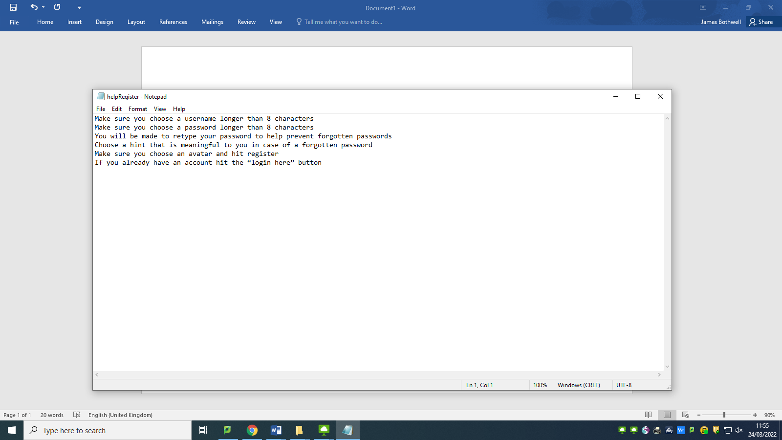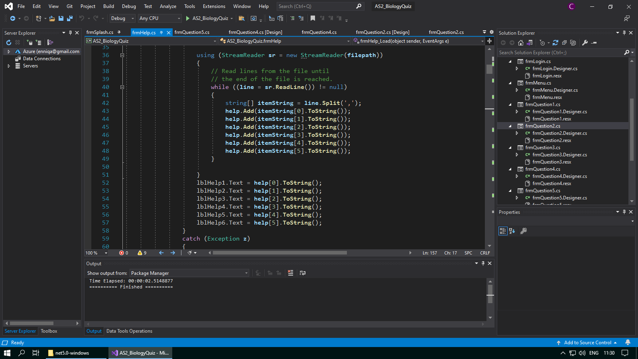

**Test #194 - Corrective Action 1 – Change text document so help all sits on the one line separated by commas**

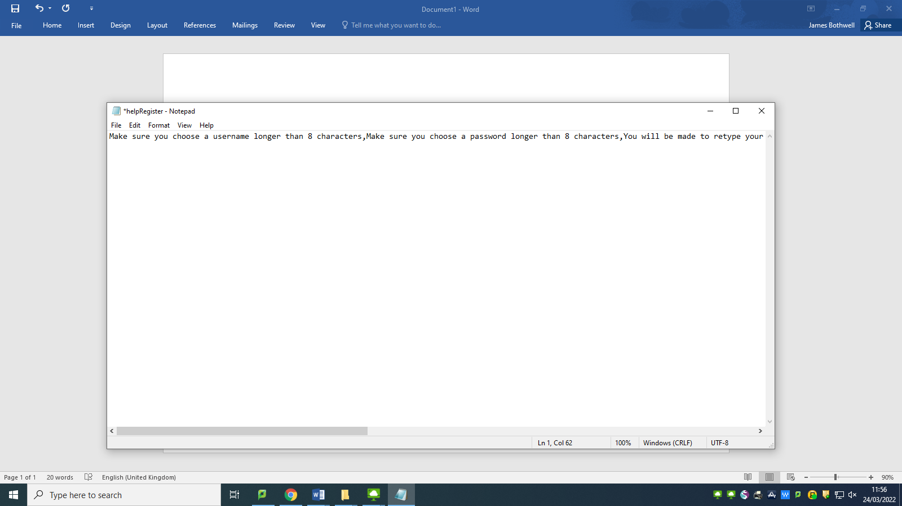

**Test #195 - Attempt to load help when player comes from frmLogin**

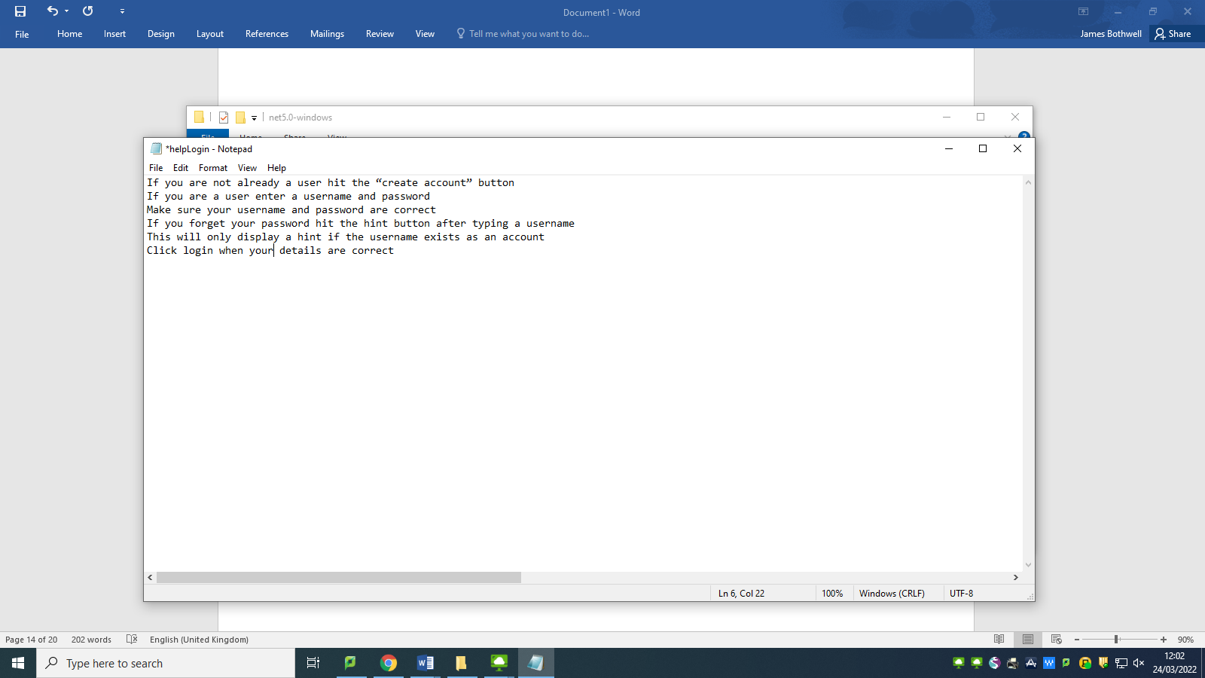

**Test #195 - Corrective Action 2 – Change text document so help all sits on the one line separated by commas**

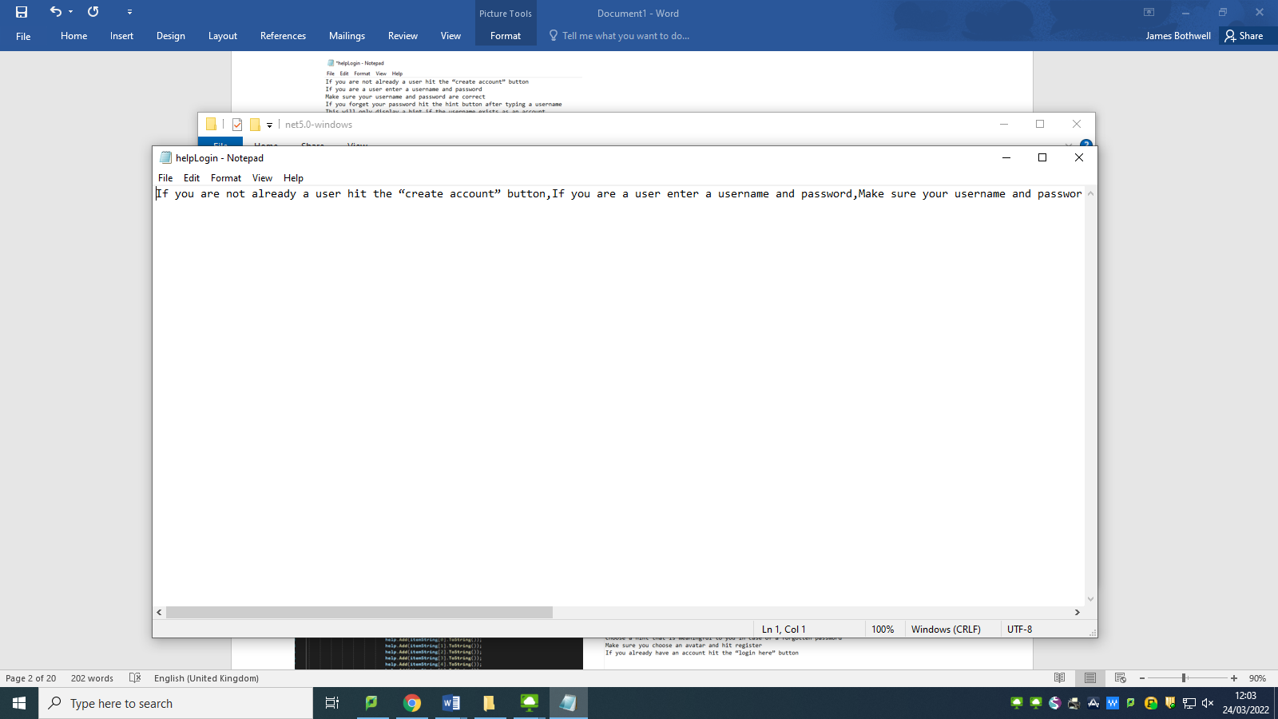

**Test #196 - Attempt to load help when player comes from frmMenu**

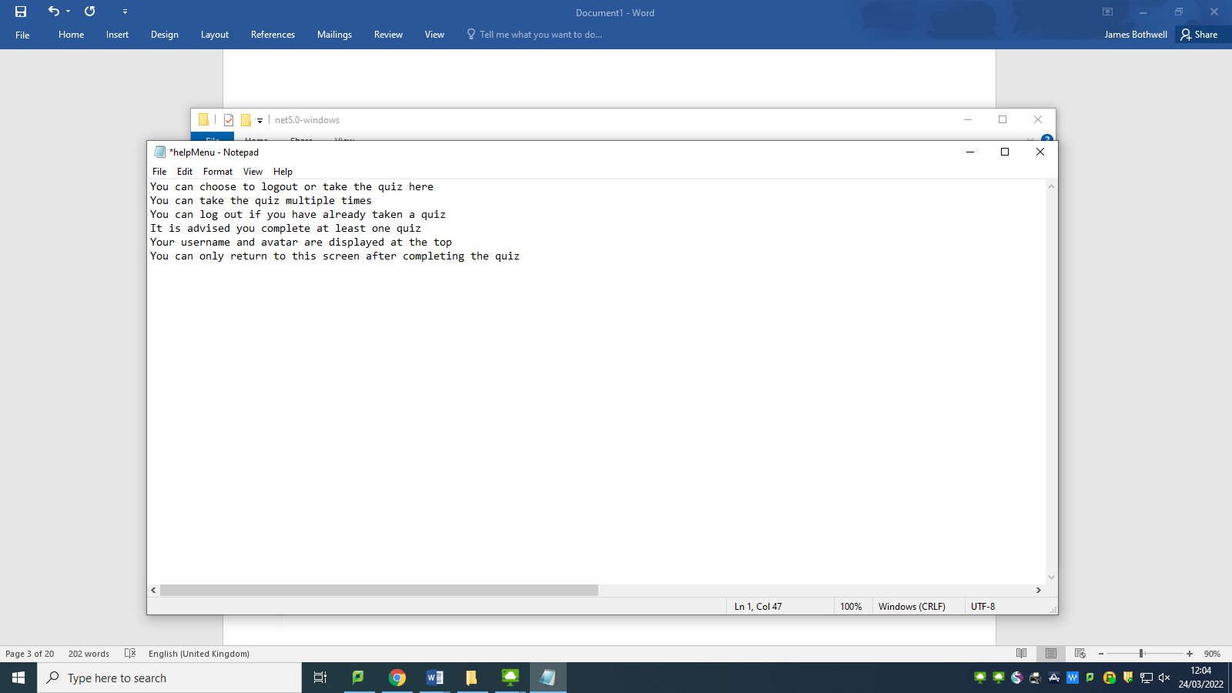

**Test #196 - Corrective Action 3 – Change text document so help all sits on the one line separated by commas**

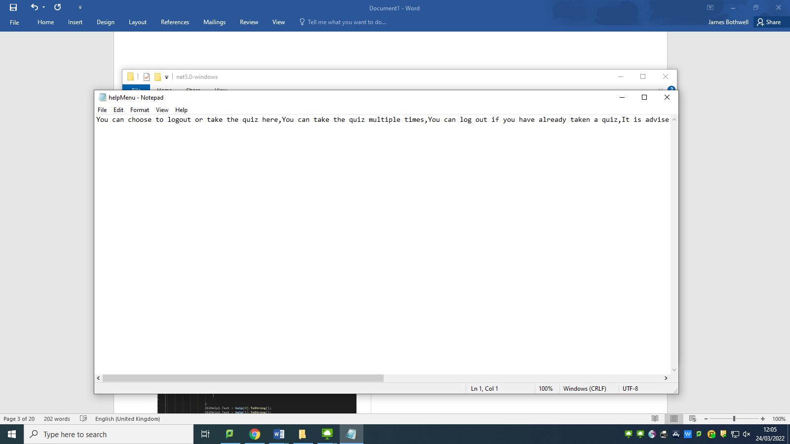

**Test #197 - Attempt to load help when player comes from frmQuestion1**

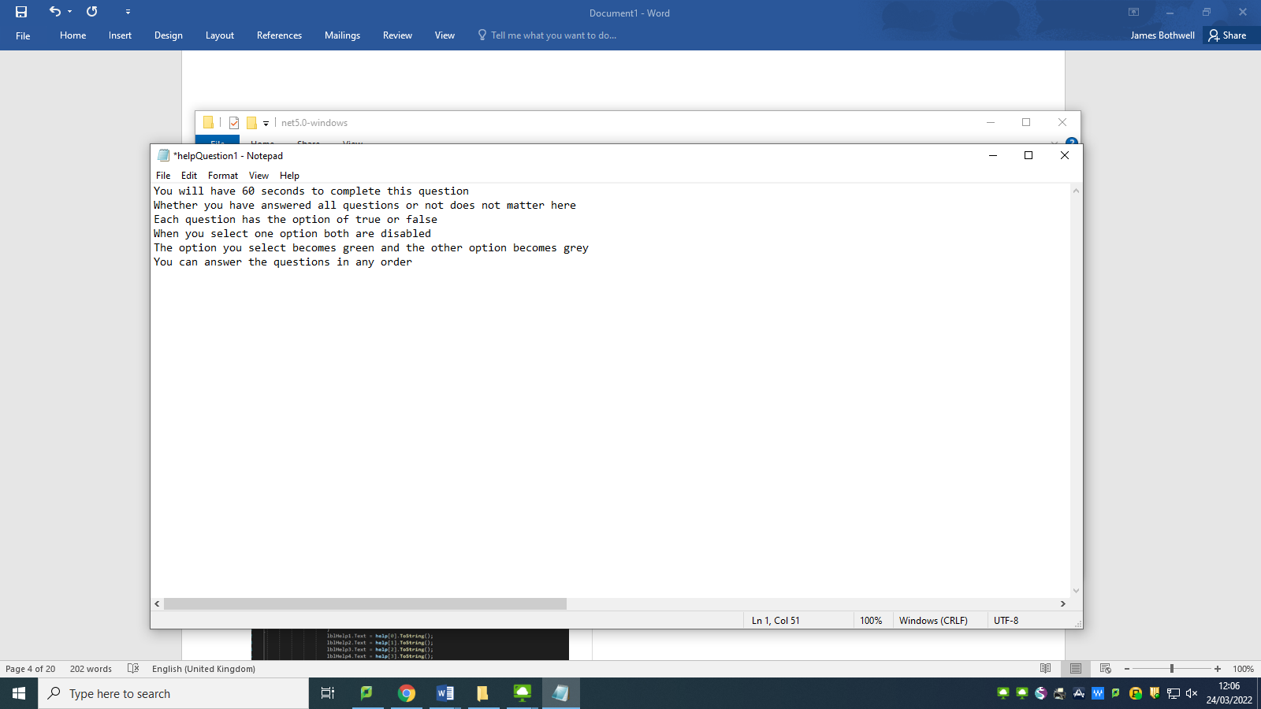

**Test #197 - Corrective Action 4 – Change text document so help all sits on the one line separated by commas**

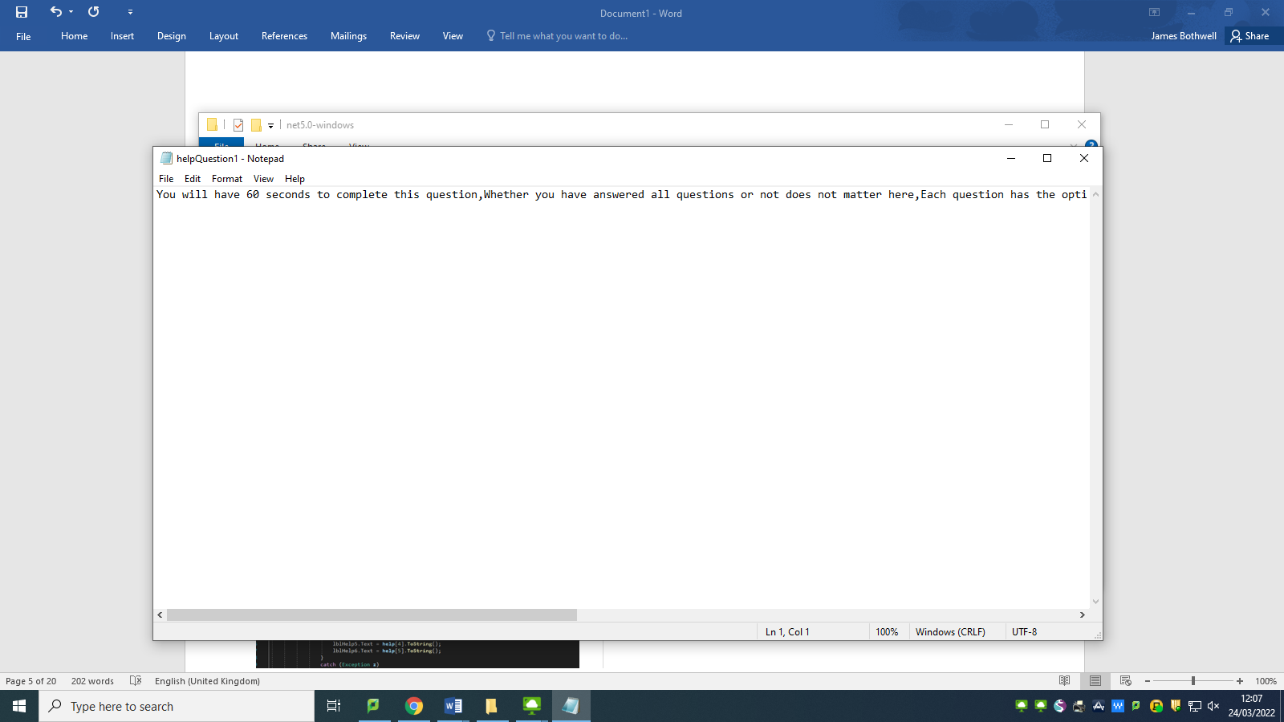

**Test #198 - Attempt to load help when player comes from frmQuestion2**

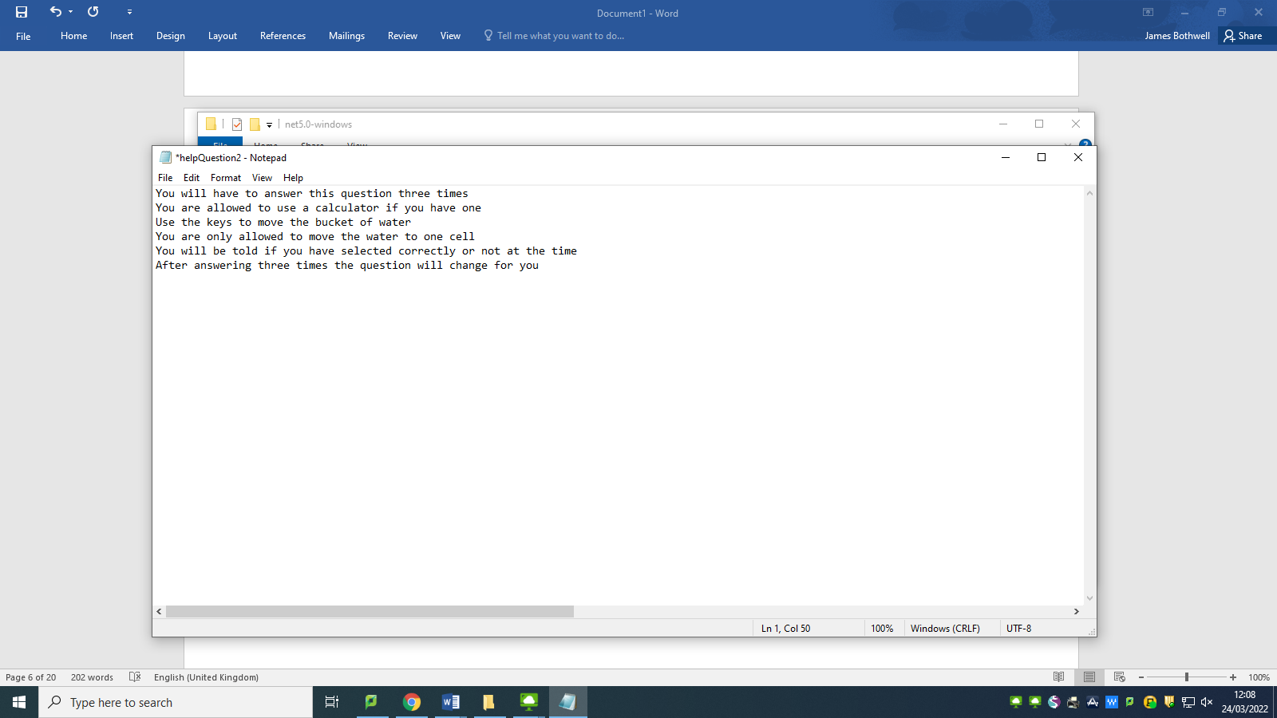

**Test #198 - Corrective Action 5 – Change text document so help all sits on the one line separated by commas**

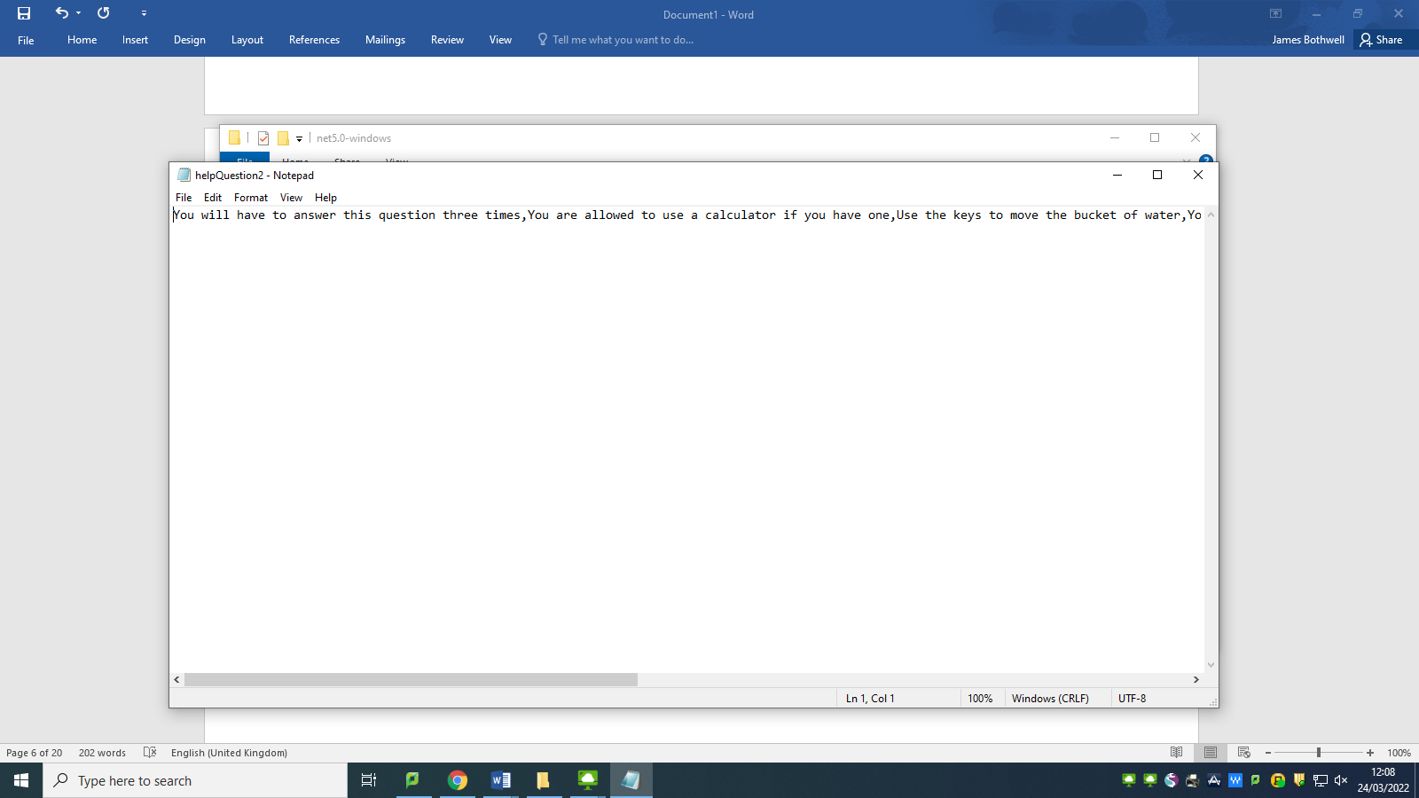

**Test #199 - Attempt to load help when player comes from frmQuestion3**

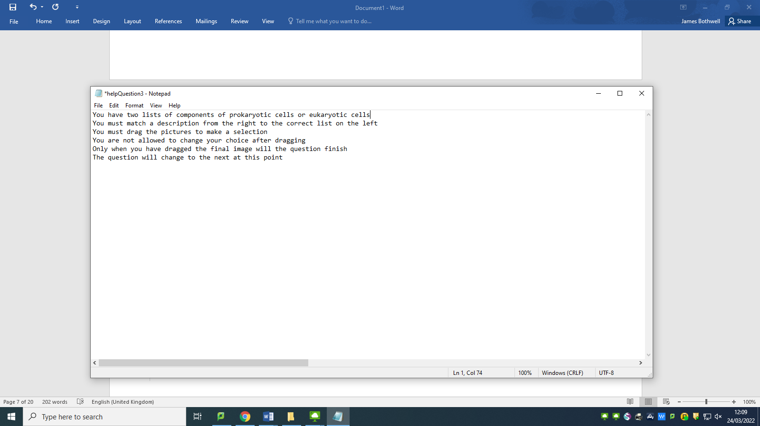

**Test #199 - Corrective Action 6 – Change text document so help all sits on the one line separated by commas**

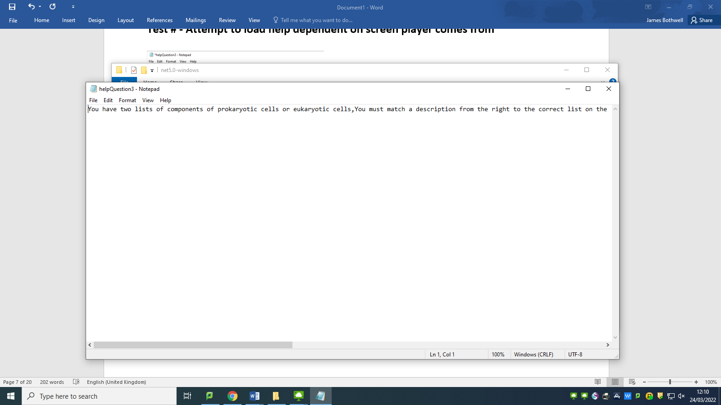

**Test #200 - Attempt to load help when player comes from frmQuestion4**

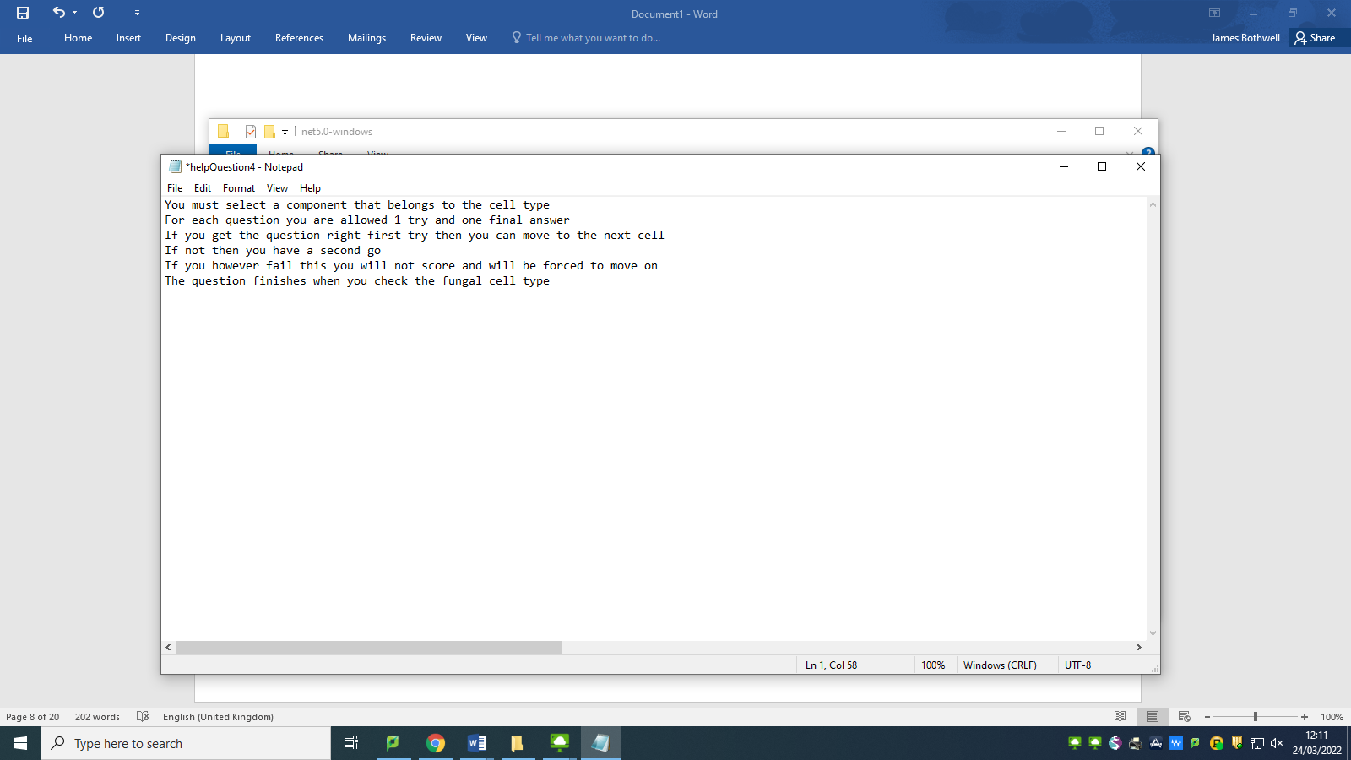

**Test #200 - Corrective Action 7 – Change text document so help all sits on the one line separated by commas**

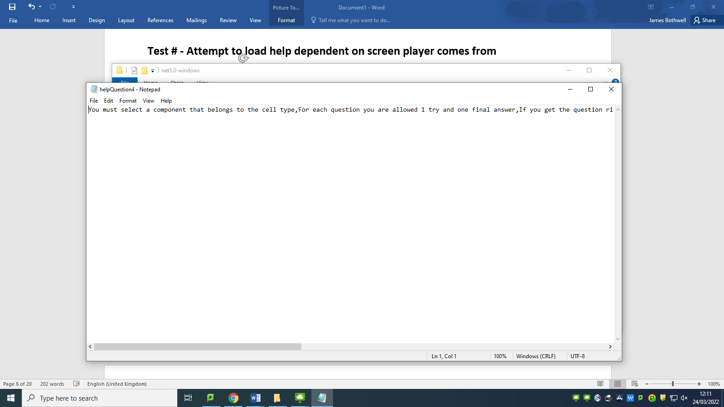

**Test #201 - Attempt to load help when player comes from frmQuestion5**

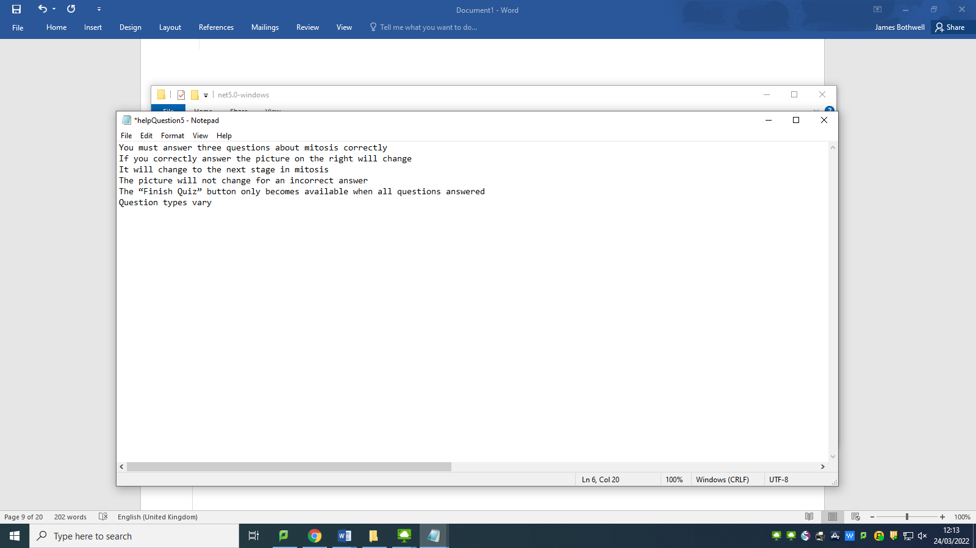

**Test #201 - Corrective Action 8 – Change text document so help all sits on the one line separated by commas**

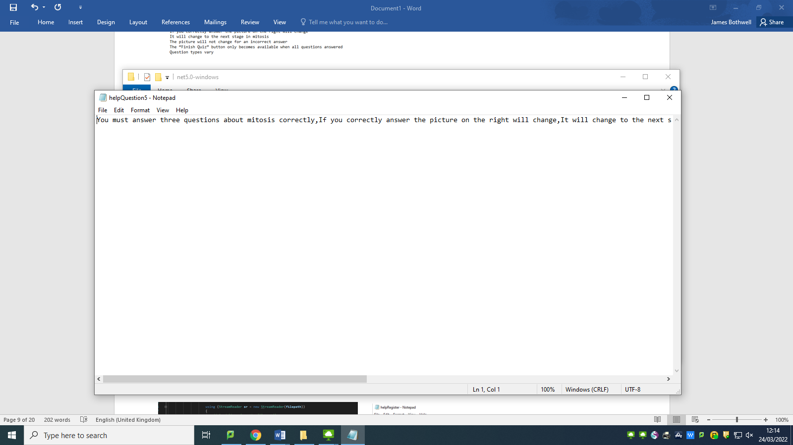

**Test #202 - Attempt to load help when player comes from frmHighScores**

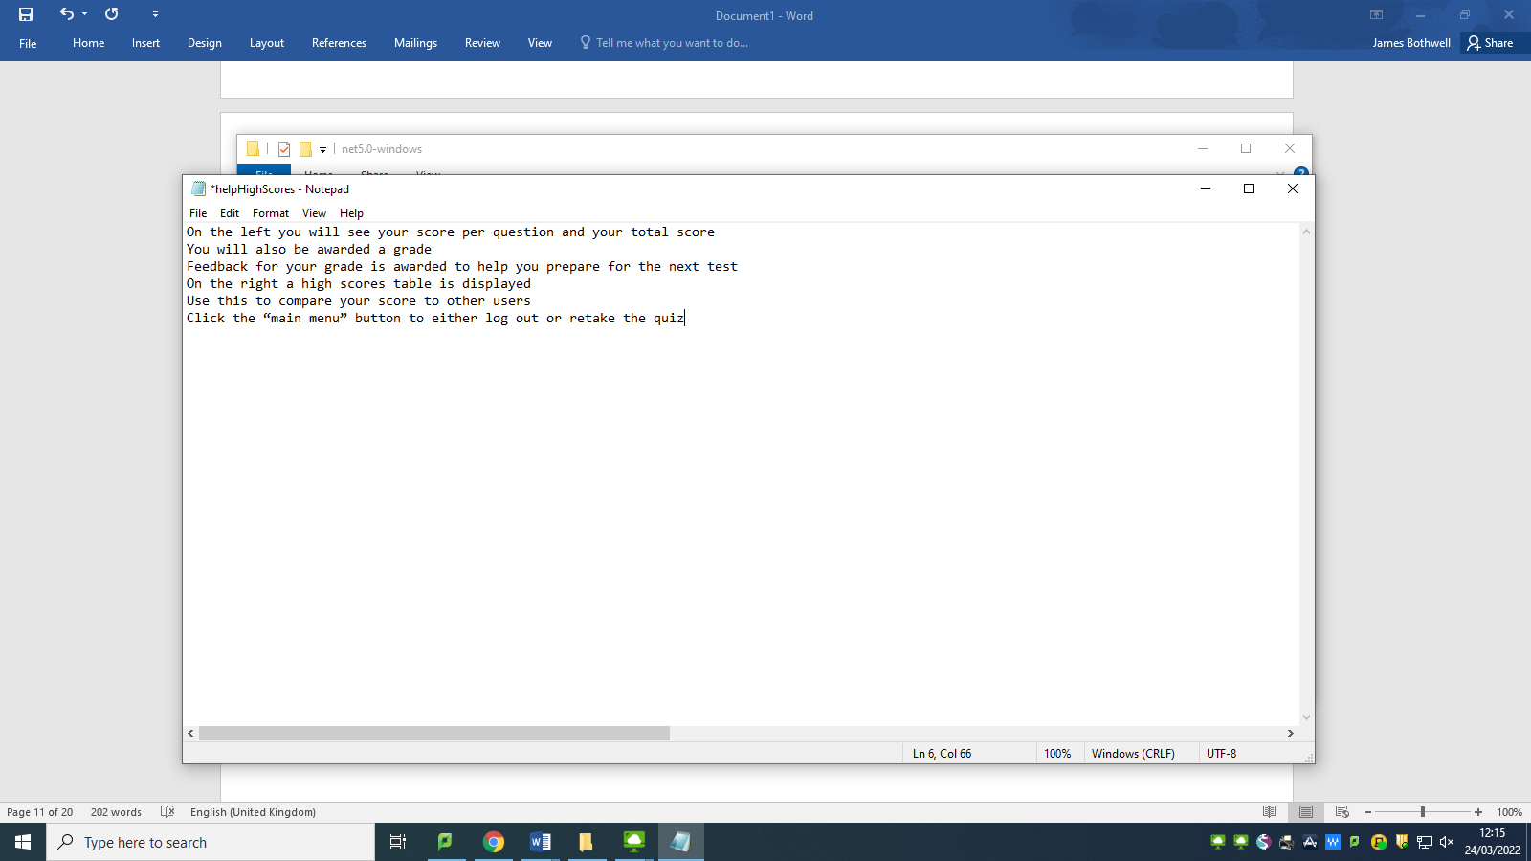

**Test #202 - Corrective Action 9 – Change text document so help all sits on the one line separated by commas**

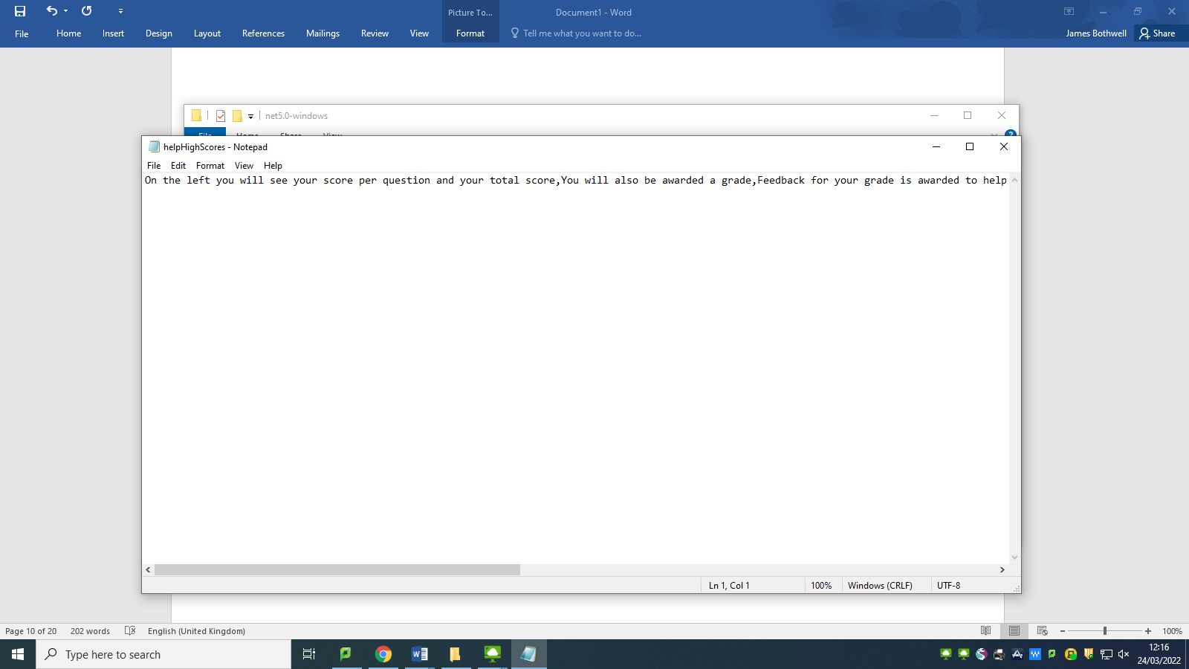

**Test #177 - Check btnCheckQ3 enables btnFinishQuiz**

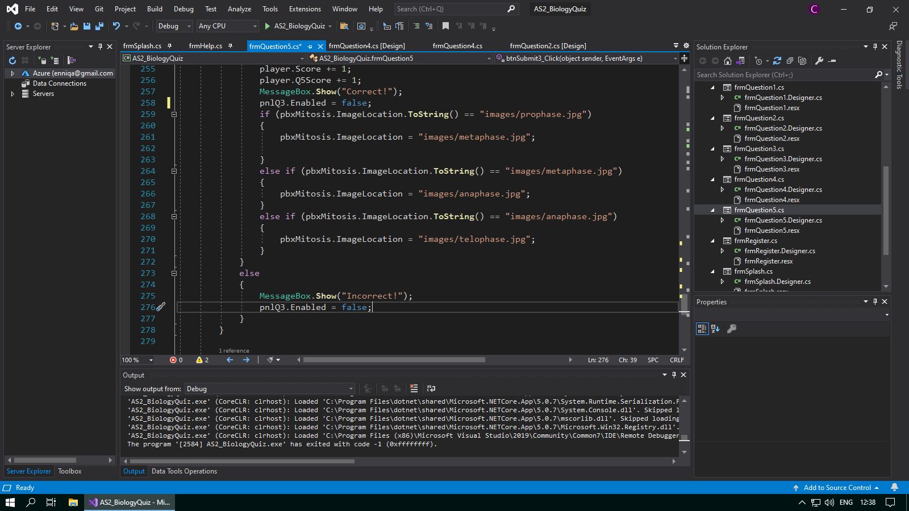

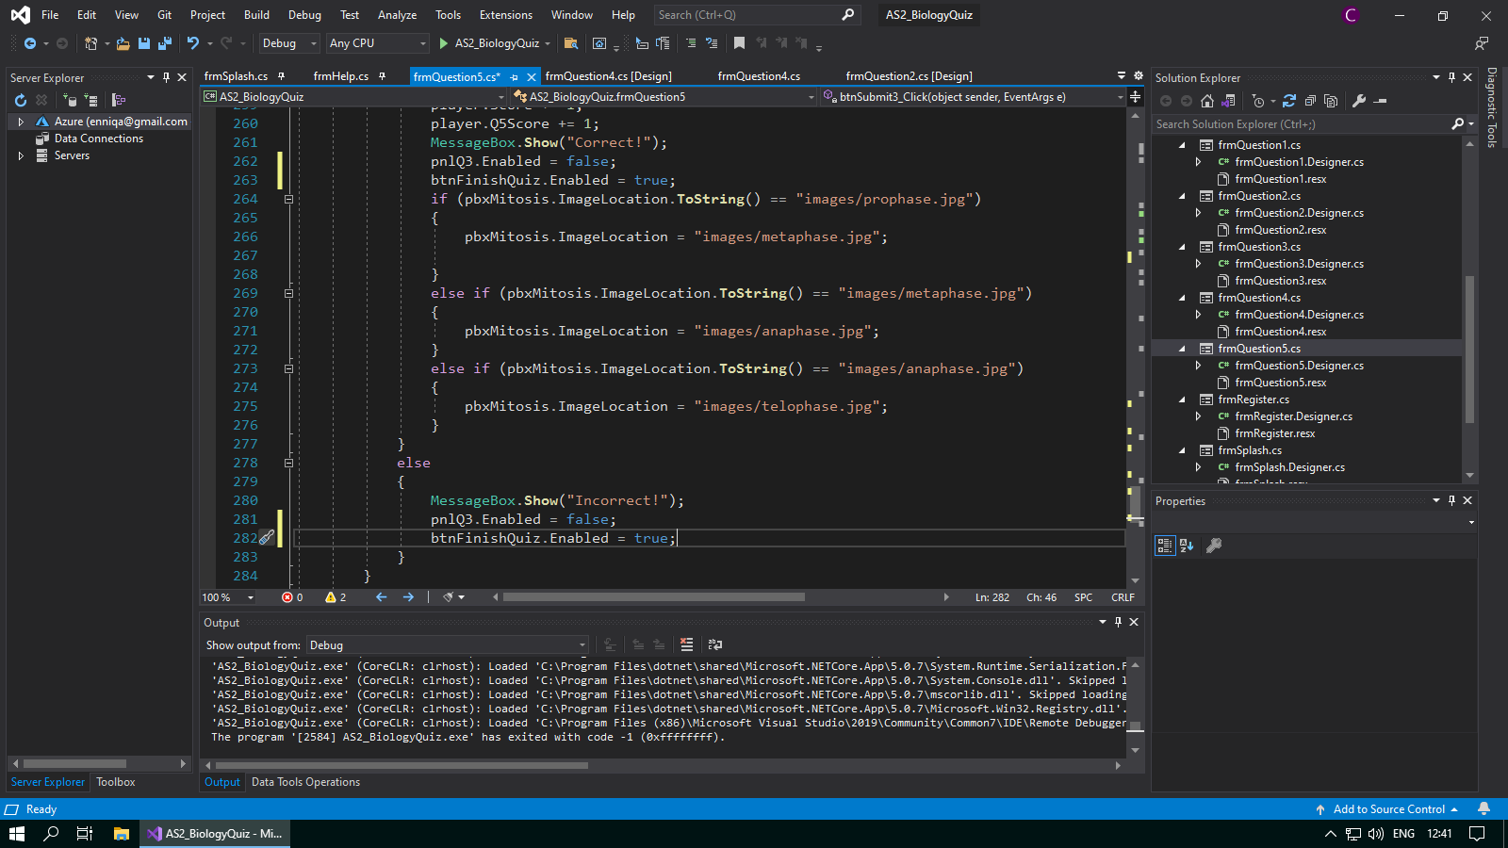**Test #177 - Corrective Action 10 – Add “btnFinishedQuiz.Enabled = true;” to both the correct and incorrect answer code sequences**

**Test #134 - Check pbxDesc1 does not throw an error when not dropped into an answer box**

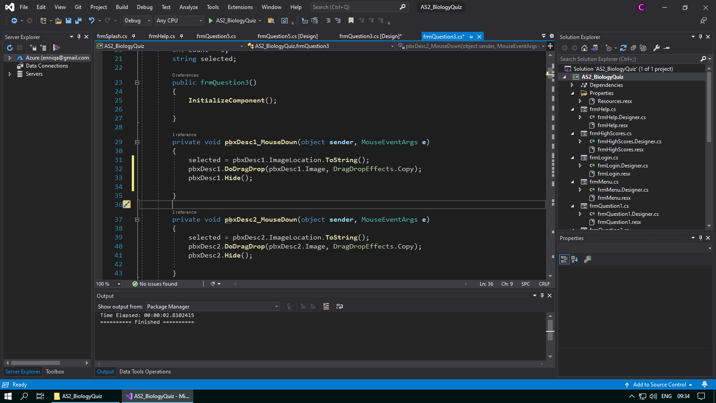

**Test #134 - Corrective Action 11 – Use a variable “temp” to check if any picture box has received the image successfully**

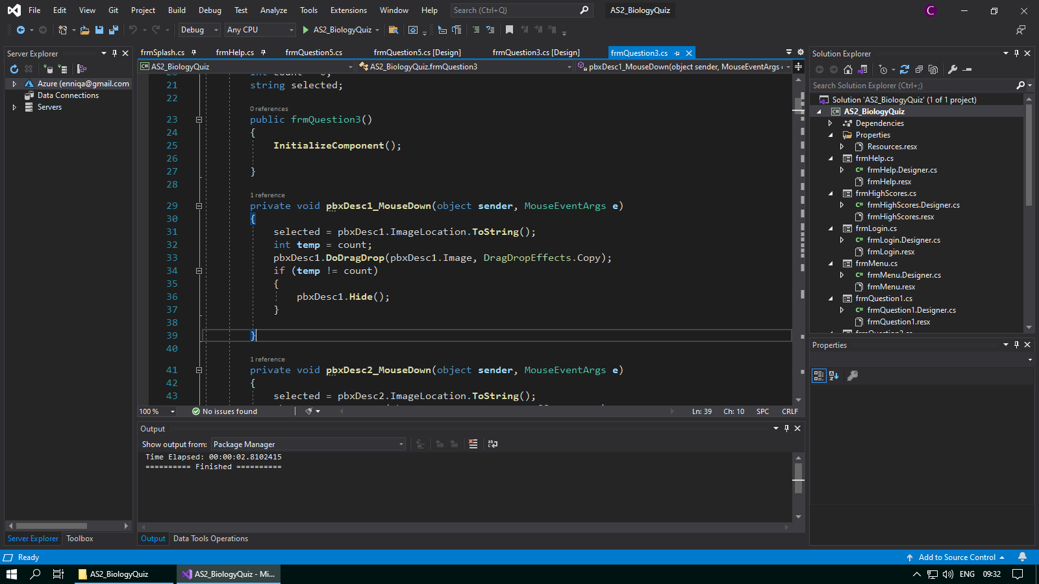

**Test #135 - Check pbxDesc2 does not throw an error when not dropped into an answer box**

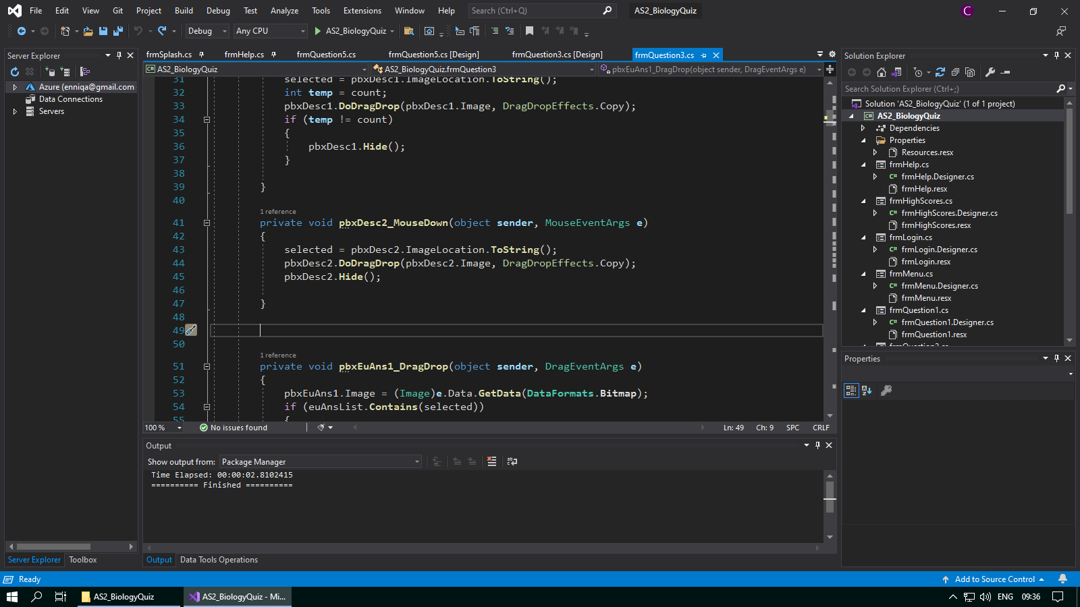

**Test #135 - Corrective Action 12 – Use a variable “temp” to check if any picture box has received the image successfully**

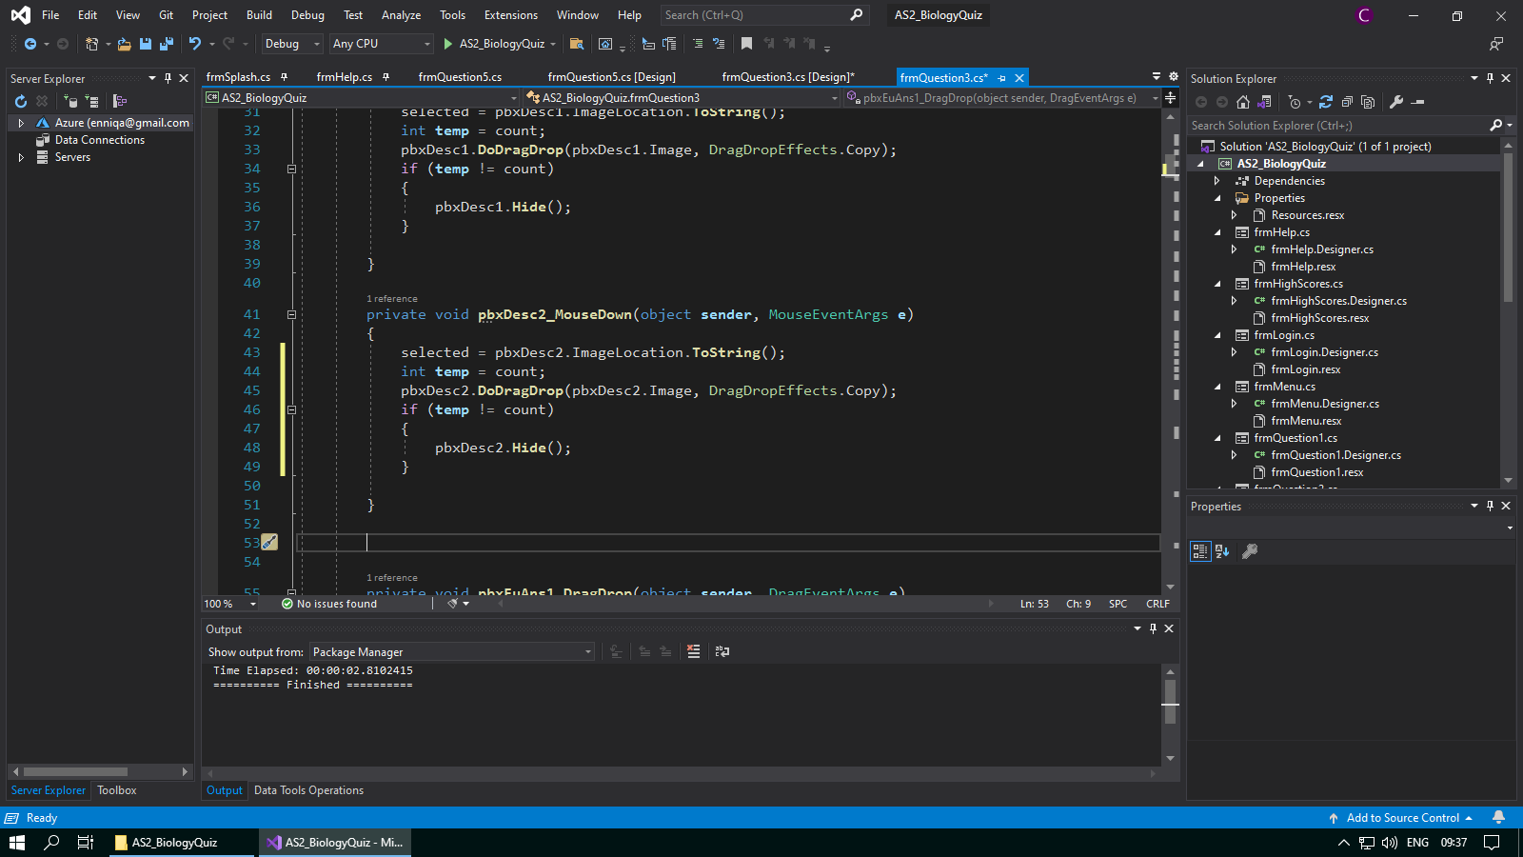

**Test #136 - Check pbxDesc3 does not throw an error when not dropped into an answer box**

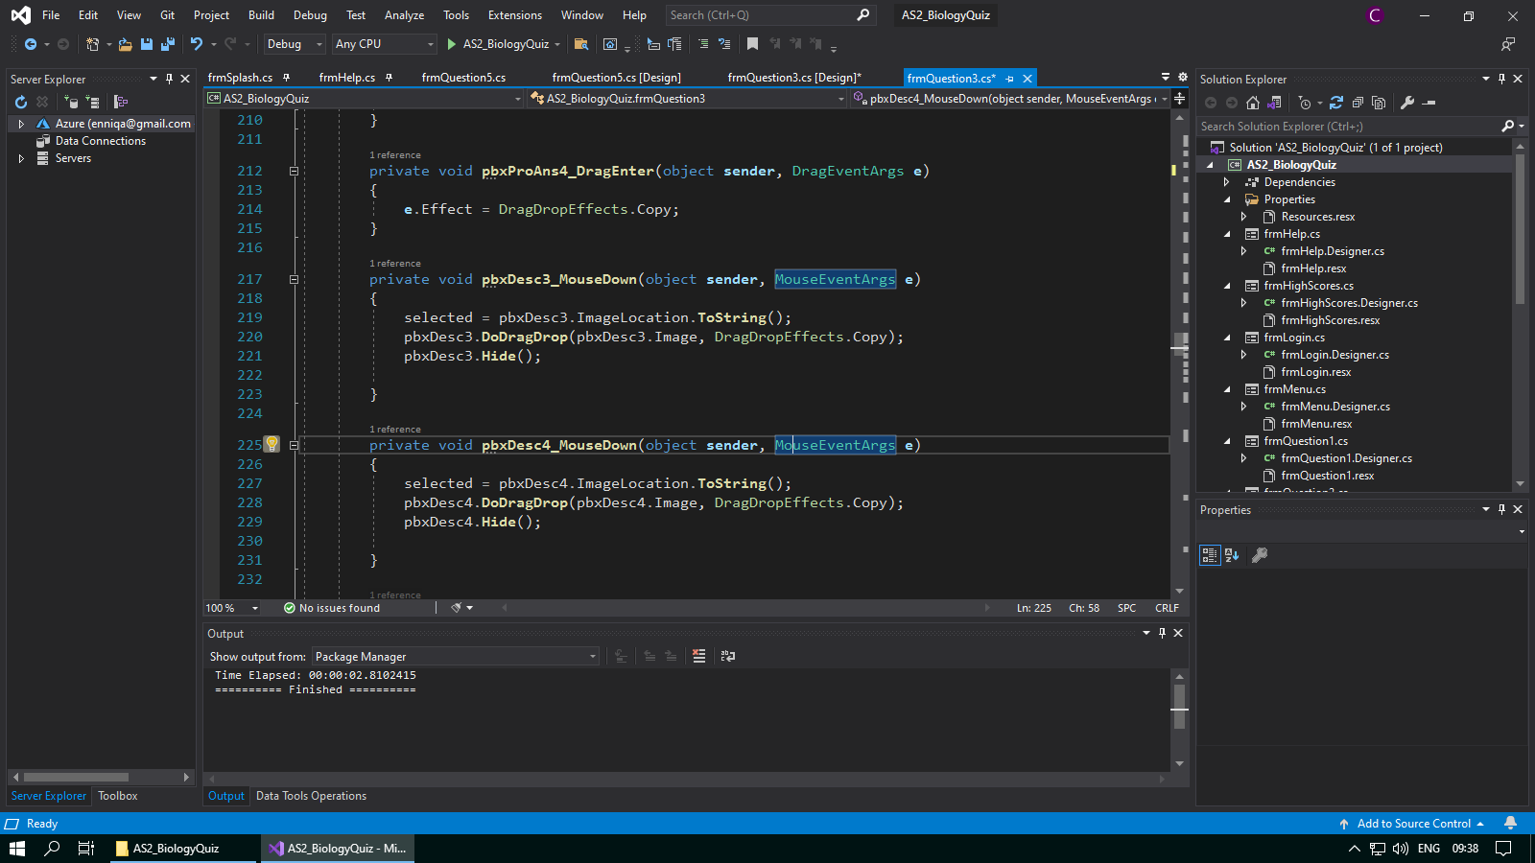

**Test #136 - Corrective Action 13 – Use a variable “temp” to check if any picture box has received the image successfully**

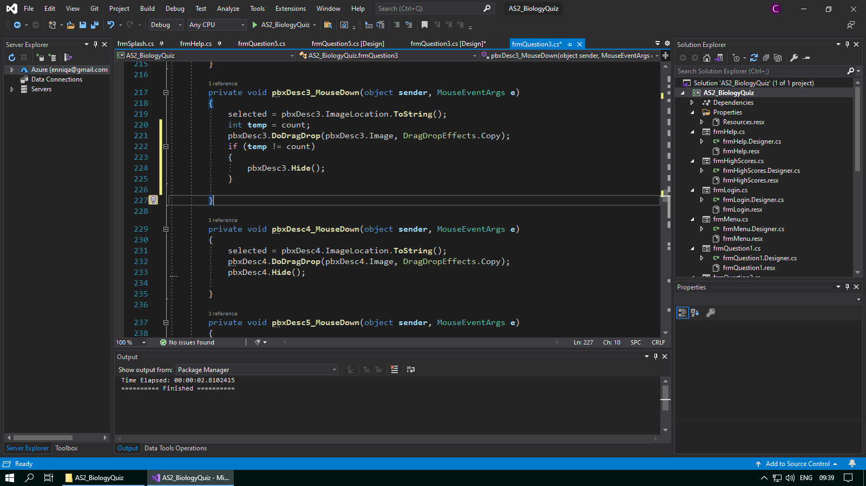

**Test #137 - Check pbxDesc4 does not throw an error when not dropped into an answer box**

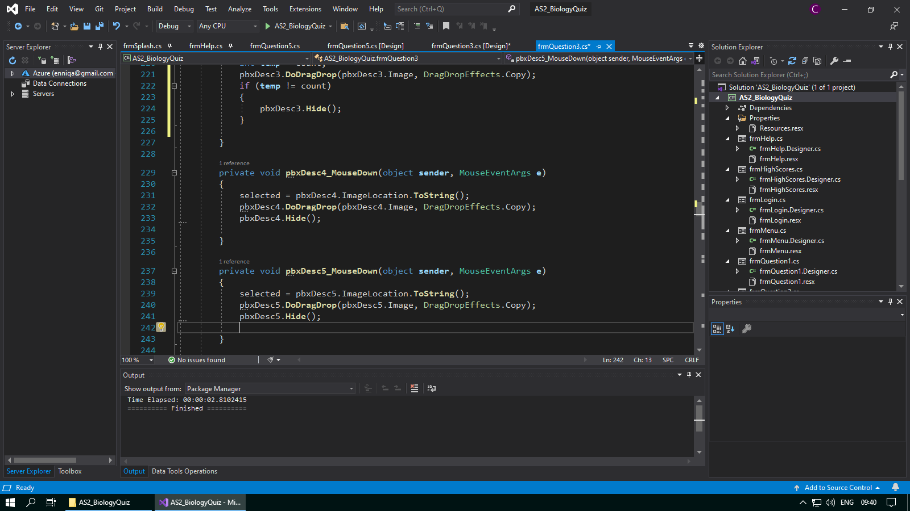

**Test #137 - Corrective Action 14 – Use a variable “temp” to check if any picture box has received the image successfully**

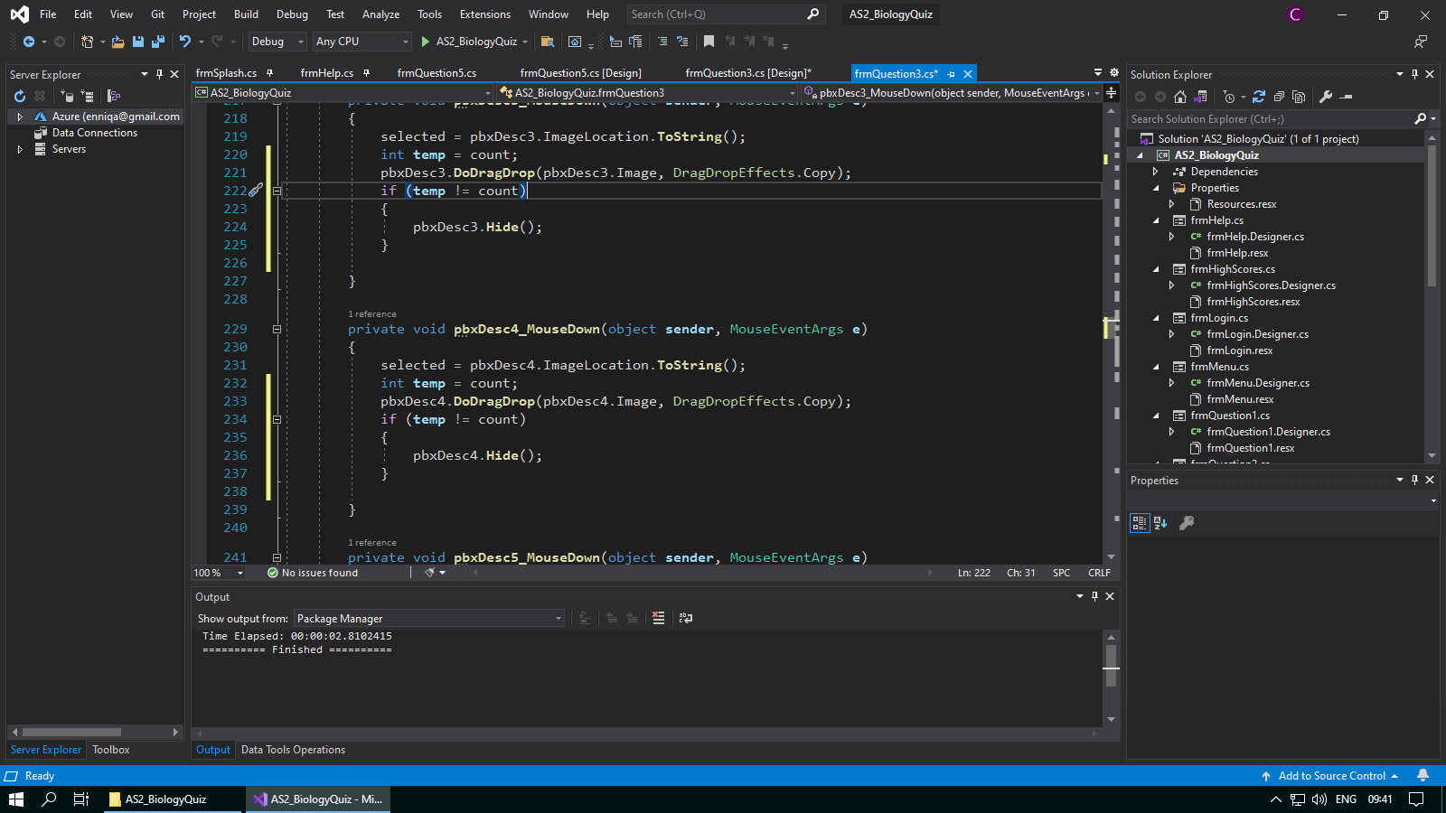

**Test #138 - Check pbxDesc5 does not throw an error when not dropped into an answer box**

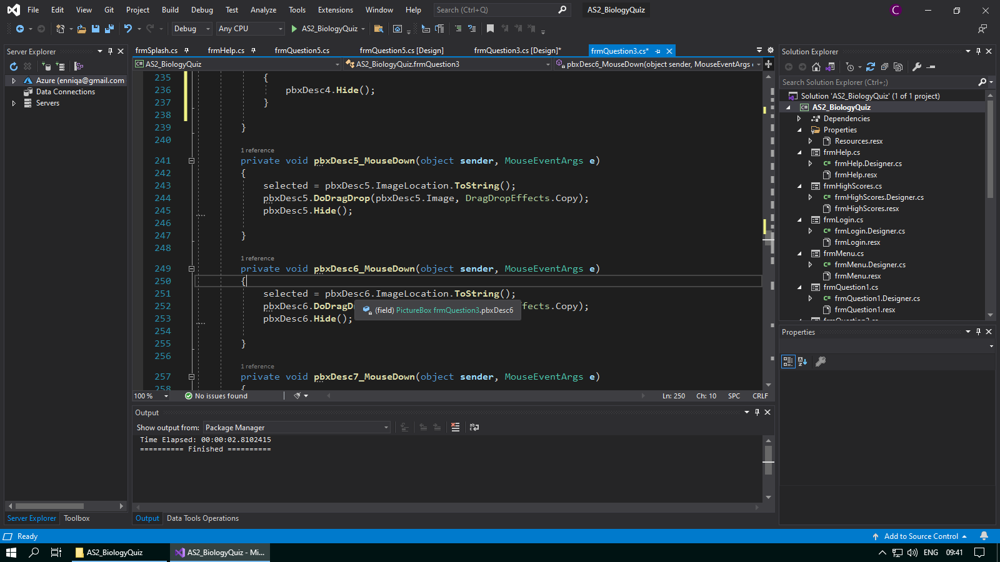

**Test #138 - Corrective Action 15 – Use a variable “temp” to check if any picture box has received the image successfully**

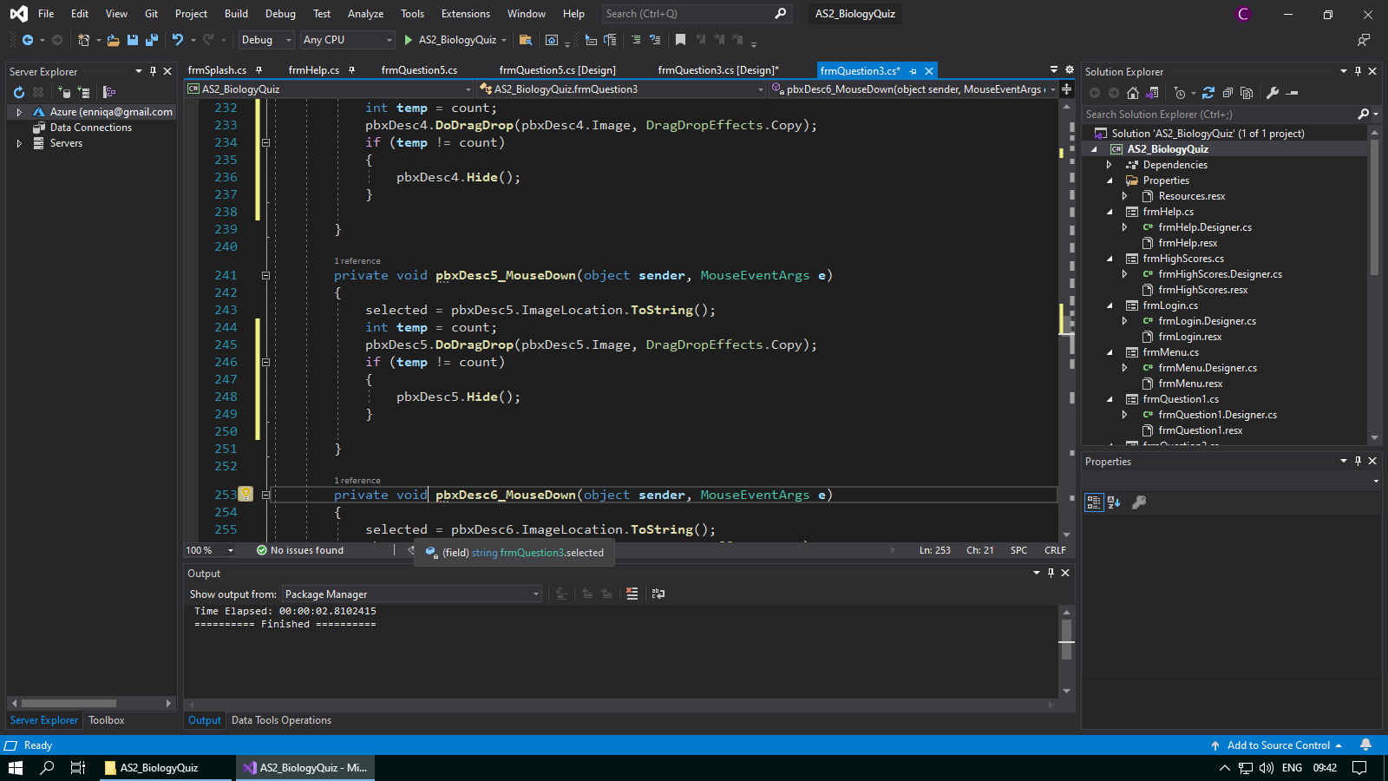

**Test #139 - Check pbxDesc6 does not throw an error when not dropped into an answer box**

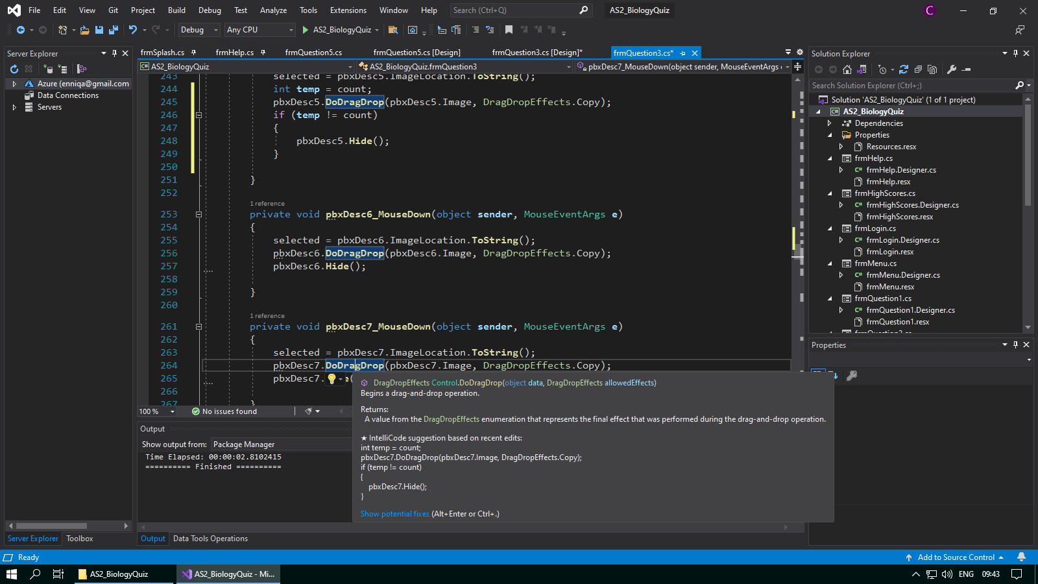

**Test #139 - Corrective Action 16 – Use a variable “temp” to check if any picture box has received the image successfully**

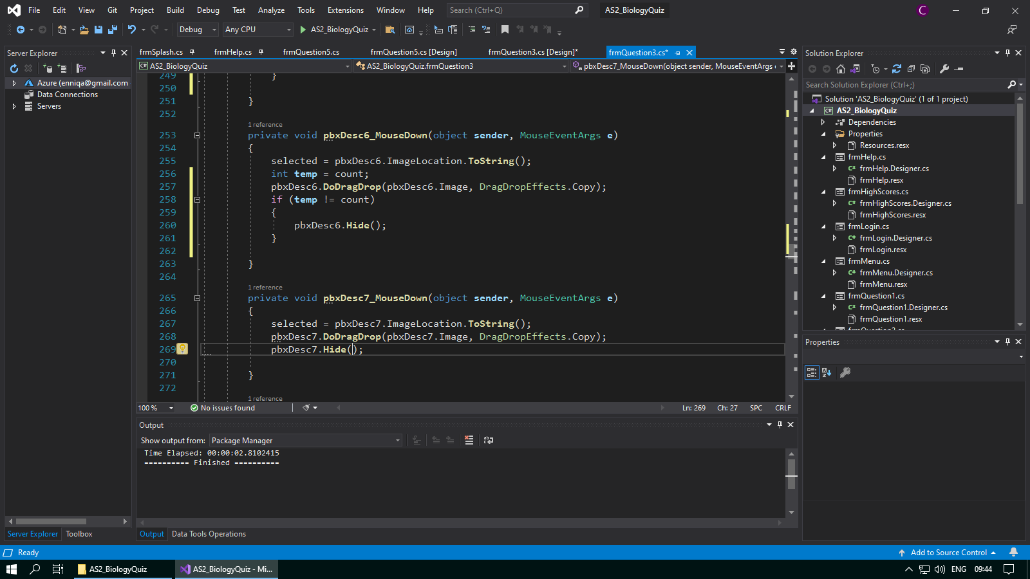

**Test #140 - Check pbxDesc7 does not throw an error when not dropped into an answer box**

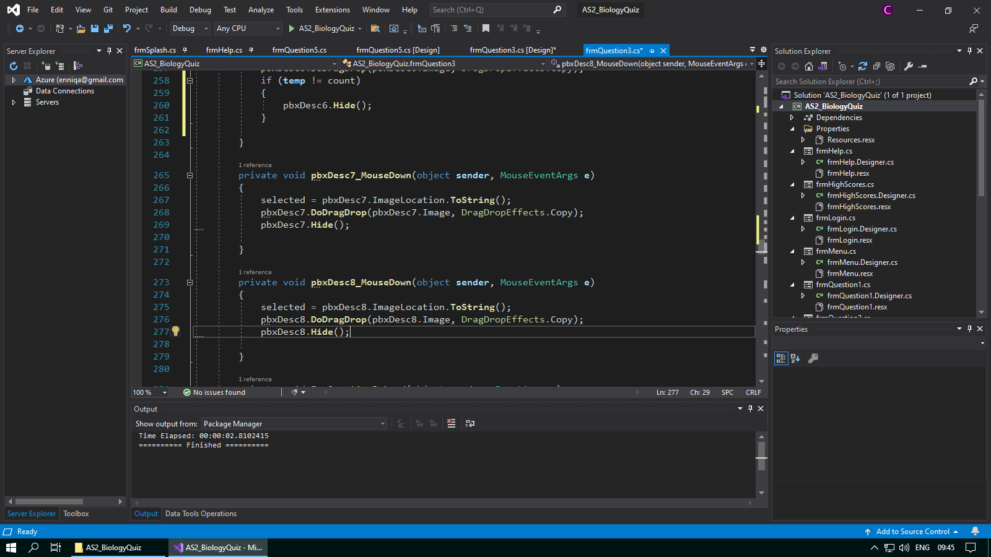

**Test #140 - Corrective Action 17 – Use a variable “temp” to check if any picture box has received the image successfully**

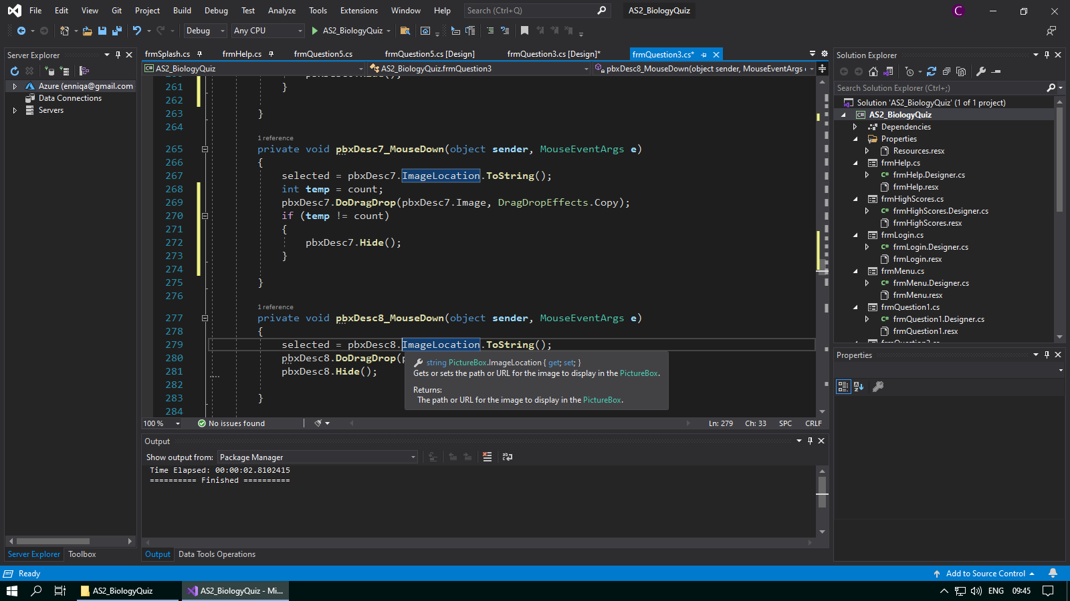

**Test #141 - Check pbxDesc8 does not throw an error when not dropped into an answer box**

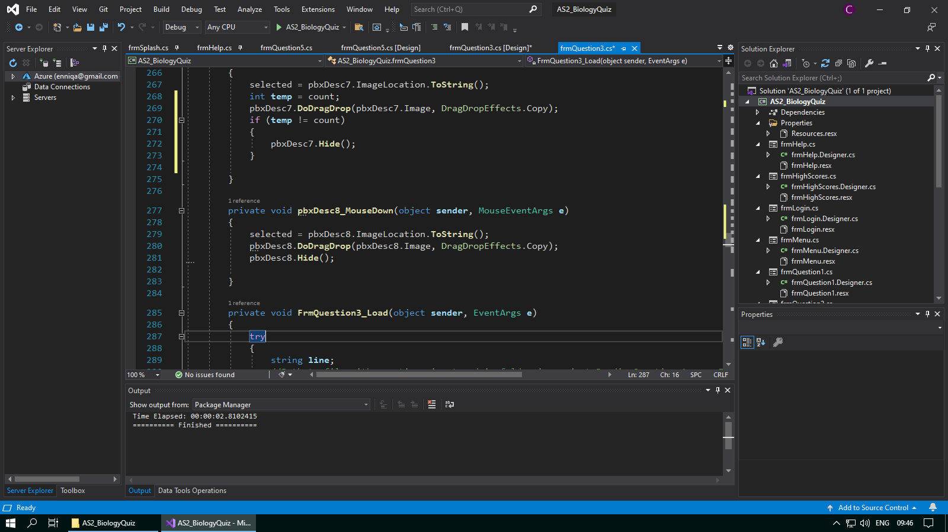

**Test #141 - Corrective Action 18 – Use a variable “temp” to check if any picture box has received the image successfully**

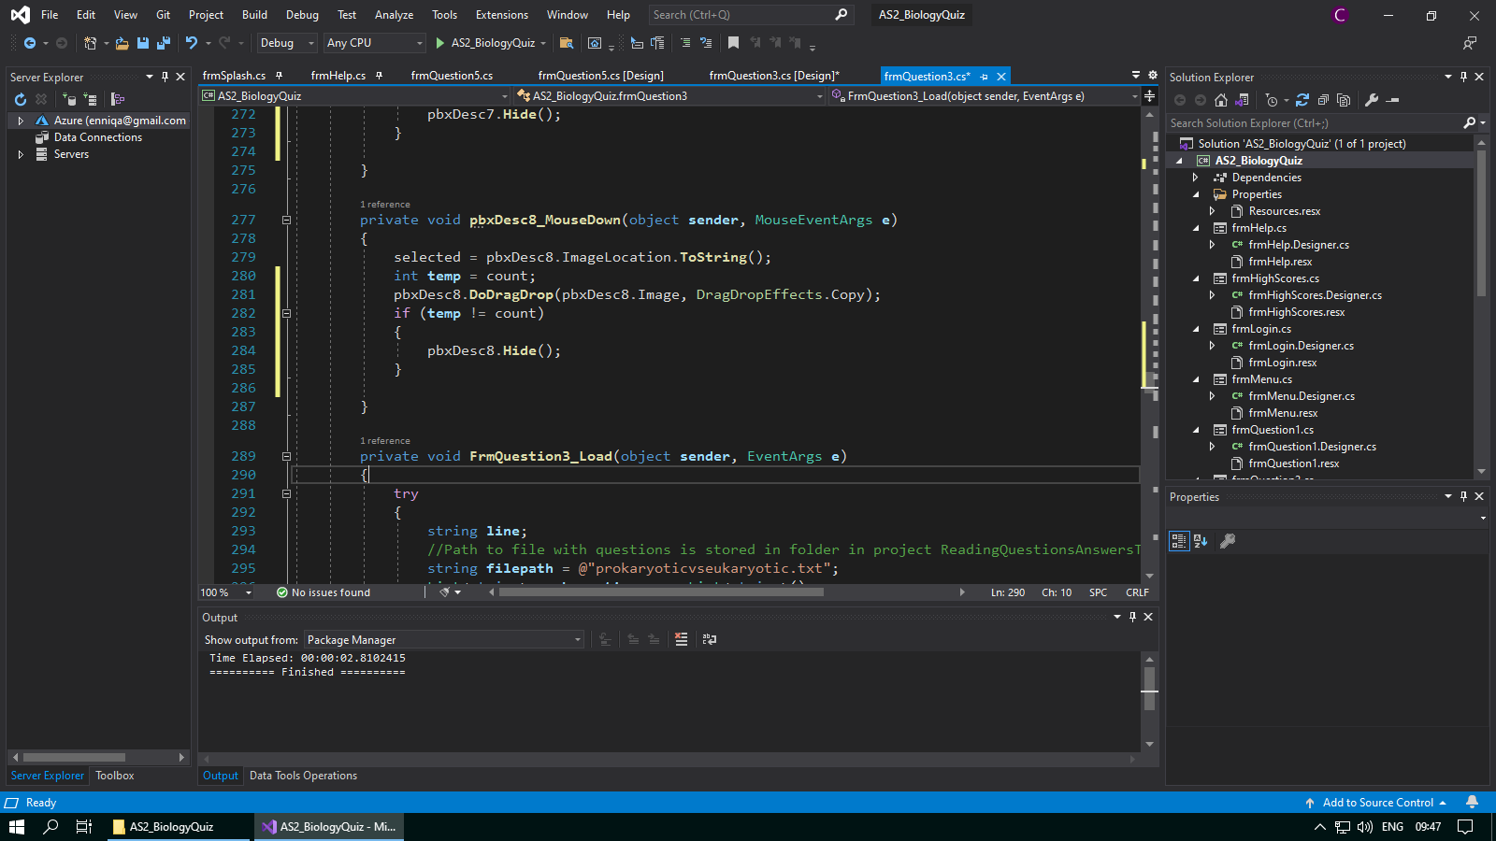

**Test #37 - Check pbxDesc8 does not throw an error when not dropped into an answer box**

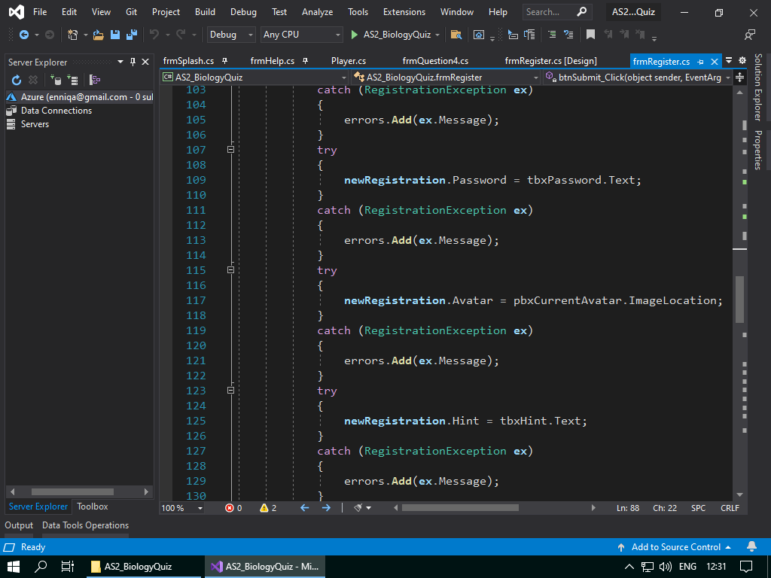

**Test #37 - Corrective Action 19 – If statement checks for a null image location of pbxCurrentAvatar before preceding onto the validation checks for the username, password, confirmed password and the hint**

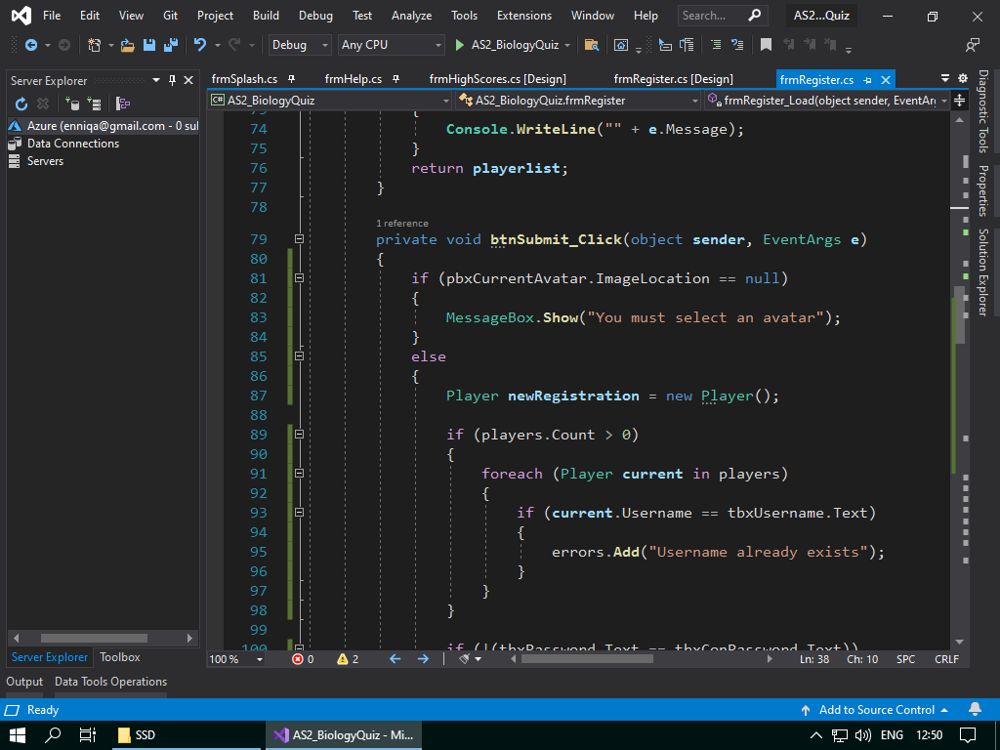

# Evaluation

1. **The game should allow users to create an account with an avatar – *fulfilled***

I gave the users the option to select from 6 different avatars. Their choice would be displayed in a chosen avatar picture box which would also be used when creating the account for the software to know which avatar was selected based off the image location of the currently selected avatar picture box.

**Seen in tests – 31, 32, 33, 34, 35, 36, 37**

1. **The player should be given feedback for each question - *fulfilled***

I saved the score for each question as the player went through the quiz so that on the high scores screen that feedback should be displayed for each question, as well as general revision feedback that is displayed dependant on the player’s grade.

**Seen in tests – 183, 184, 185, 186, 187, 188**

1. **The game should have a clean and professional interface design - *fulfilled***

I designed the interface with the fact it was a biology quiz in mind, so I used a colour scheme consisting of greens, whites and blacks to stick to a continuous and clean design. As well, the logo was chosen to be a tree to also tie in with the interface colours and subject matter.

1. **The player should be able to login to their account - *fulfilled***

The player will be able to login to their account via the login menu. On this menu as well the user is able to navigate to the register screen, or if they feel lost they can use the help section found in the menu strip if they encounter any problems.

**Seen in tests – 12**

1. **Players should be allowed a hint for their forgotten password, provided their username is correct – *fulfilled***

I made the login so that if a player has forgotten their password, but knows their username, they can enter their username into the username textbox and click the hint button, and it should display the hint they assigned themselves on account creation if the username matches correctly

**Seen in tests – 10, 27, 28, 29, 30**

1. **The game should randomise questions to create a different experience for each user – *fulfilled***

The randomisation of questions creates a new experience for each player, and it also allows for players that have already completed the quiz to replay the quiz and have a new experience. I found it also helped to increase the replay ability by making the quiz more entertaining.

1. **The player should be able to sign out without the need to close the game - *fulfilled***

Whether the player has just made an account and will do the quiz at a later time, or the player has finished the quiz and would like to logout of their account but not close the game, the main menu offers a logout option for users that means that can sign out of the game without closing it.

**Seen in tests – 45**

1. **A help screen should always be available for the player – *fulfilled***

I believe that a help page on every screen apart from the splash is extremely important to the game. It helps players that find themselves stuck on what to do to figure out what actions they should take. A help screen also can be used to give additional rules for each question to the player.

**Seen in tests – 13, 40, 46, 74, 97, 142, 159, 179, 190**

1. **The game should include a range of ways to answer questions, for example using keys or drag and drop – *fulfilled***

I incorporated a wide range of ways to answer question. Question 1 makes use of true and false questions, Question 2 makes use of movement of a picture box by keys, Question 3 is a drag and drop style question, Question 4 is a radio button guess based question and Question 5 is a mix with the addition of a changing picture box.

**Seen in tests – 51, 52, 53, 54, 55, 56, 57, 58, 59, 60, 61, 62, 63, 64, 65, 66, 67, 68, 69, 70, 82, 83, 84, 85, 86, 87, 88, 89, 90, 91, 92, 93, 94, 95, 96, 102, 103, 104, 105, 106, 107, 108, 109, 110, 111, 112, 113, 114, 115, 116, 117, 118, 119, 120, 121, 122, 123, 124, 125, 126, 127, 128, 129, 130, 131, 132, 133, 134, 135, 136, 137, 138, 139, 140, 141, 147, 148, 149, 150, 151, 152, 153, 154, 155, 156, 157, 158, 164, 165, 166, 167, 168, 169, 170, 171, 172, 173, 174, 175, 176, 177**

1. **Timers should be included on at least one of the questions to make the game more challenging - *fulfilled***

I decided to implement a timer on the first question to make it more challenging. The first question is a true or false based question, where the player has 60 seconds to answer 10 true or false style questions. If they answer all of them before the time is up, then they can move onto the next question.

**Seen in tests – 71, 73**

1. **A high score board should be available for players to allow comparison of scores - *fulfilled***

A high scores table will be displayed to the player after they complete the quiz. I found this to be useful as well to motivate students as it allows them to compare their answers to other players and gives a sense of competition and increases the replay ability of the game.

**Seen in tests – 182**

1. **The game should save a player’s total score - *fulfilled***

It is crucial that the game saves the player’s total score. This is used to be also displayed on the high scores page and is crucial in determining whether the player has achieved a new high score. The total score can also be used to decide a grade for the player.

**Seen in tests – 181**

1. **The game should store the player’s account for future login access – *fulfilled***

I made sure that the account details for each player were all saved on account creation to allow users to play the game on the same account after the close the software. This also increases replay ability because the user does not have to create a new account every time they play the game.

**Seen in tests – 38**

1. **There should be restrictions and validation checks in place for account creation, for example passwords must be longer than 8 characters – *fulfilled***

I made it so that usernames and passwords must be 8 characters or longer and password and confirm password boxes must be the same. As well as this, validation checks for the likes of valid and invalid data are in place as well.

**Seen in tests – 15, 16, 17, 18, 19, 20, 21, 22, 23, 24, 25, 26**

1. **The help screen should be used to display the rules to the player - *fulfilled***

I designed the help screen so that it would load in the rules or help for the screen that the player comes from. You cannot see the rules or help for other screens on the help screen. This design makes the help screen easy to use.

**Seen in tests –195, 196, 197, 198, 199, 200, 201, 202**

1. **A progress bar should be displayed on questions with timers to tell a player how long they have left on the question – *fulfilled***

The progress bar is used to display to the player how long they have left on Question 1. It works off the timer on Question 1 and is a visual guide for the player. It also makes the question more exciting for the player due to a visual countdown to try and beat.

**Seen in tests – 72**

1. **The player’s username and avatar must be displayed on every question – *fulfilled***

I decided to add this into the software because I felt that it made the interface design much more interesting and also helped to make the quiz more personal for the player as they can always see their username and avatar so it is more likely that they will enjoy the quiz more.

**Seen in tests – 42, 43, 48, 49, 79, 80, 99, 100, 144, 145, 161, 162**

1. **The game must contain login, register, and main menu screens that are easy to navigate – *fulfilled***

I designed the login menu to have a simplistic design, with username and password fields, and hyperlinks to either register or to display a hint if the player has forgotten their password. The register has user details on the left and avatar selection on the right, and the main menu contains two functions, to either take the quiz or logout so it is also easy to navigate.

1. **The player must be able to replay the game if they want – *fulfilled***

If the user wants to replay the game, they can do so by selecting the take quiz button again in the main menu. This results all their scores (apart from high score) to 0 and allows them to try and achieve a new high score.

**Seen in tests – 44, 189**

1. **Instructions for each question should be available at the top of each screen on each question - *fulfilled***

I decided that it was best to display a set on mini instructions for each question below the title of the question for the user to have quick access to the rules when the move onto a question. However, if they feel they need more guidance then they can navigate to the help screen.

1. **The splash screen should contain a GIF image and the company name – *fulfilled***

The splash screen should display a GIF image of a tree growing (the company logo) and the name Evergreen Studios, which is the company game. This aids the software in achieving a more professional, industry standard design.

**Seen in tests – 1**

1. **Players should be made to confirm their password when registering to prevent them registering with a password they didn’t intend - *fulfilled***

Making the users enter their password again on account creation helps to ensure that they do not register with a password that contains a typo and this will help reduce the number of players that are unable to login again after logging out for the first time.

**Seen in tests – 23, 24, 25, 26**

1. **A menu-strip should be present on all questions for access to extra help – *fulfilled***

The menu strip was implemented on all questions and screens apart from the splash screen to provide extra help for the player if they select the “Help”, and as well information about the software if the player selects the “About” section.

**Seen in tests – 13, 14, 40, 41, 46, 47, 74, 78, 97, 98, 142, 143, 159, 160, 179, 180, 190, 191**

1. **A login screen should allow players to enter their username and password, have hints for forgotten passwords and the option to create an account – *fulfilled***

On the login screen, users can use the text boxes to enter a username and password. A hint can be displayed if the user enters a valid username but no password in a forgotten password situation, and a hyperlink to create an account is also available. Validation checks for entering a username and password are also in place, such as checks valid, invalid and extreme data.

**Seen in tests – 2, 3, 4, 5, 6, 7, 8, 9, 10, 11**

1. **The player’s total score of the previously completed questions should be displayed – *fulfilled***

As the player progresses through the quiz, I thought it would be useful for them to see a running score for the total for all the previous questions they have completed. It can work as an indicator to the player if they should focus more and try to improve their current score.

**Seen in tests – 50, 81, 101, 146, 163**

1. **Timed questions should be paused when help is displayed - *fulfilled***

I felt it was necessary that when the user opens the help screen on Question 1 that the timer for the Question should be paused. On Question 1 as well, a red button saying “RESUME TIMER” will be displayed and the timer will only start again if the user closes the help screen via the “Close Help” button.

**Seen in tests – 75, 76, 77**